**functional requirements document**

|  |  |  |  |  |  |
| --- | --- | --- | --- | --- | --- |
| **Project Name** | : | MoSA Portal | **Date** | : | 30/Jun/2019 |
| **Requirement #** | : |  | **Created by** | : | Shakboua Zaid |

Requirement Title

Extranet – User Preferences

Detailed Description

User preferences provide intranet (employee) users an easy configuration settings for tailoring the portal to their particular working style.

This include settings for their preferred display language, their external accounts passwords, and the like.

Preferences settings are a user-level customization that affect only intranet (employee) user’s view.

Requirements

User preferences is a Webcenter Portal native service (OOTB service), it is a set of configuration and customization (user-level), nothing stored as data rows in Webcenter schema table, customization and personalization will be stored in MDS.

Use Cases

## Access Preferences

|  |  |
| --- | --- |
| Task name | Access Preferences |
| Task owner | MOSA Intranet User (employee) |
| Description | The user will access to his preferences page. |
| Task preconditions | * The user logs on to the system. |
| Input | The user login. |
| Output | The user preferences page. |
| Task outcome | Preferences. |

|  |  |
| --- | --- |
| Task Main Flow | |
| # | **Actor action** | **System response** |
|  | Select “Preferences” from the dropdown control (username). | The system will redirect to User Preferences system page |

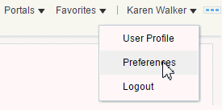

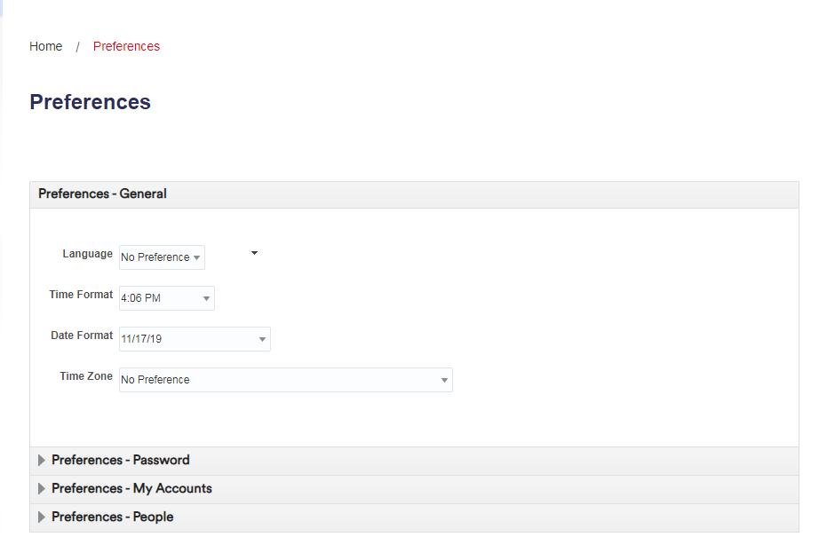

## Setting Preferences

|  |  |
| --- | --- |
| Task name | Setting Preferences |
| Task owner | MOSA Intranet User (employee) |
| Description | The user will set his preferences. |
| Task preconditions | * The user logs on to the system. * The user accessed the Preferences page. |
| Input | The user selections and entered values. |
| Output | The user preferences set. |
| Task outcome | Save, Apply. |

|  |  |
| --- | --- |
| Task Main Flow | |
| # | **Actor action** | **System response** |
|  | Select from the sidebar navigation the preferences tab to be set (general, password, My Accounts, etc…) | The system will open the selected preferences sub-page. |
|  | Select the desired preferences options and settings and click “Save” or “Apply”.  *Note: some of the preferences do not need to be saved or applied to take effect.* | The system store the new options and settings as personalization for the logged in user and directly take effect and applied. |

### Setting Preferences (General)

|  |  |
| --- | --- |
| Task name | Setting Preferences (General) |
| Task owner | MOSA Intranet User (employee) |
| Description | The user will set his general preferences. |
| Task preconditions | * The user logs on to the system. * The user accessed the Preferences page. |
| Input | The user selections and entered values. |
| Output | The user preferences set. |
| Task outcome |  |

|  |  |
| --- | --- |
| Task Main Flow | |
| # | **Actor action** | **System response** |
|  | Select from the sidebar navigation “General” preferences tab | The system will open “General” sub-page in preferences page. |
|  | Select preferred language from the dropdown control “Language” | The preferred language selected and set. |
|  | Select the preferred time format from the dropdown control “Time Format” | The preferred time format selected and set. |
|  | Select the preferred Date format from the dropdown control “Date Format” | The preferred date format selected and set. |
|  | Select the preferred time zone from the dropdown control “Time Zone” | The preferred time zone selected and set. |

### Setting Preferences (Password)

|  |  |
| --- | --- |
| Task name | Setting Preferences (Password) |
| Task owner | MOSA Intranet User (employee) |
| Description | The user will change his password. |
| Task preconditions | * The user logs on to the system. * The user accessed the Preferences page. |
| Input | The user new password. |
| Output | The new password set. |
| Task outcome | Save |

|  |  |
| --- | --- |
| Task Main Flow | |
| # | **Actor action** | **System response** |
|  | Select from the sidebar navigation “Password” preferences tab | The system will open “Password” sub-page in preferences page. |
|  | Enter current password in “Old Password” and enter the new password in “New Password” and confirm the new password in “Confirm New Password” then click “Save” | The new password set. |

Developers & Contributors Tasks to Enable the Service

|  |  |  |
| --- | --- | --- |
| **Task** | **Application** | **Responsibility of** |
| Enable Preferences Page for Users by Adding the Link for Preferences to the Portal. | Webcenter Portal | Portal Contributor |

Updates Log