Print Out reports
Use Case ID: UTL Reports 001
Use Case Name: Backend Employment reports
Description |  | Allow PAM users to Print Out reports through back-end “counter”.
Stakeholders
Service Channels |  | Backend users
Analyzed by |  | Abdelrhaman Almomani
SRS documented by |  | Abdelrhaman Almomani
Developed by
Pre-conditions
# | Description |  | Business Rules
1. | Check “General Requirements” above.
Basic Scenario
# | Description |  | Business Rules
 | User should access the screen.
 | The user should enter the request code.
 | The user should click on “جلب التقرير” button to preview the report.
Prototype
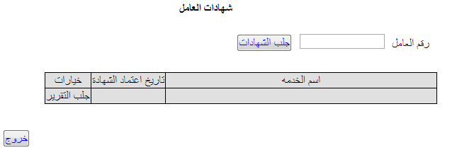

Data/Fields/Buttons
MPM_GENERAL_REPORTS. CIVIL_ID = The entered “civil_id” from the screen
# | Arabic Description | English Description | Field Type | Allowed Data | Data Source | Mandatory | Editable? | type | VISIBLE | Size | Business Rules
MPM_GENERAL_REPORTS
Main master section (Search section)
 | اسم الخدمه | SERVICE_ID | Number |  | SERVICE_ID | No | Yes | Display | Yes
 | تاريخ اعتماد الشهادة | Create Date | Date |  | Created_date | No | Yes | Display | Yes
 | رقم الطلب الداخلي | Trans_id | Number |  | Trans_id | No | No | N\A | No
 | متغير اضافي | Extra parametar | Number |  | Extra_parametar | No | No | N\A | No
 | الرقم المدني للعامل | CIVIL ID | VRACHAR |  | CIVIL_ID | No | No | N\A | No | 20
 | Get reports | جلب التقرير | If service_id = 96 then call this report :  /PampReportsII/emp_towhomitmayconcernservlet?pTransId=&pUserId=&pIsSalaryVisible=  The Needed Params From The Screen :  1) pTransId (Trans_id from view)  2) pUserId (The LoggedIn User)  3) pIsSalaryVisible (Extra_parametar from view)  If o_service_id = 97 then call this report :  /PampReportsII/emp_careersequencecertificateservlet?pTransId=&pUserId=&pIsSalaryVisible=  The Needed Params From The Screen :  1) pTransId (Trans_id from view)  2) pUserId (The LoggedIn User)  3) pIsSalaryVisible (Extra_parametar from view)

