**functional requirements document**

|  |  |  |  |  |  |
| --- | --- | --- | --- | --- | --- |
| **Project Name** | : | MoSA Portal | **Date** | : | 01/Jul/2019 |
| **Requirement #** | : |  | **Created by** | : | Shakboua Zaid |

Requirement Title

Intranet - Blogs

Detailed Description

Blogs provide a useful tool for discussing and/or evangelizing any type of idea, strategy, or point of view.

Typically, each blog contains various blog posts, with the most recently added blog post displayed at the top.

Blogs invite readers to comment on the overall concepts. Intranet (employee) users will be able to tag the posts by keywords that might be useful when they want to directly find and reach these posts in the future.

Requirements

Blogs functionality in WebCenter Portal requires that Content Server is the content repository. However, it is important to be aware that blogs are managed by WebCenter Portal, not by Content Server. Thus, folder settings in Content Server have no effect. For example, specifying a default profile on a Content Server folder in which blogs are stored has no effect on the creation of new blog documents in that folder.

Use Cases

## Create New Blog

|  |  |
| --- | --- |
| Task name | Create New blog |
| Task owner | MOSA Intranet Blogger |
| Description | The blogger will create a new portal page using the page style “Blog”. |
| Task preconditions | * The user logs on to the system. * The user is an Intranet blogger. |
| Input | New page with page style “Blog”. |
| Output | Blog page. |
| Task outcome | Create Page, Cancel. |

|  |  |
| --- | --- |
| Task Main Flow | |
| # | **Actor action** | **System response** |
|  | Select “Create Page” from the portal editing dropdown control at the top right of the portal | The system will prompt with the page style selection page. |
|  | Select the page style “Blog” and click “Use This” | The system open the new page wizard. |
|  | At the page information (first step), enter the page name (for English page title), enter page description (for Arabic page title) and click “Next” | The wizard will forward to the next step. |
|  | Set the desired layout for this blog (page) then click “Next” | The wizard will forward to the final step. |
|  | Set the security settings for the blog (page) then click “Create” | The new Blog page is created, a folder containing all the posts in this blog is also created at the content repository |

|  |  |
| --- | --- |
| Task exceptional Flow | |
| # | **Actor action** | **System response** |
|  | If the user select “Cancel” in any step | The new page wizard closed. |

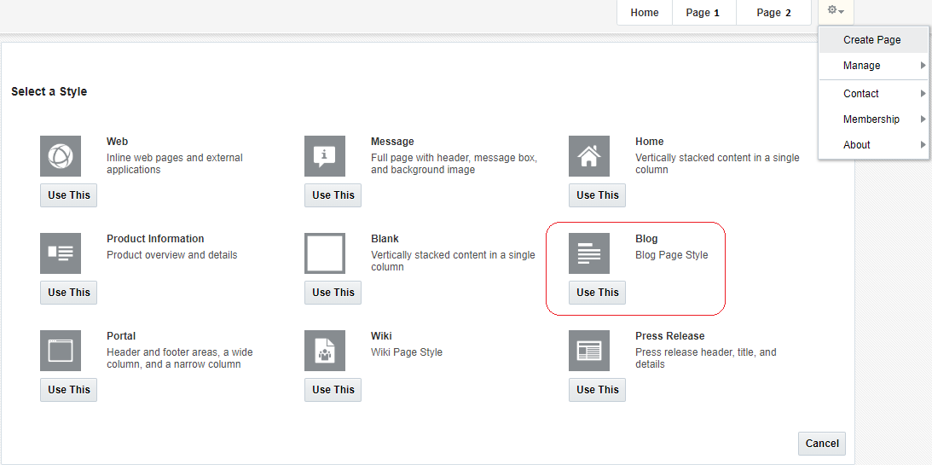

## Create New Post

|  |  |
| --- | --- |
| Task name | Create New Post |
| Task owner | MOSA Intranet Blogger |
| Description | The blogger will create a new post to the selected blog. |
| Task preconditions | * The user logs on to the system. * The user is an Intranet blogger. |
| Input | The Blog. |
| Output | The new post in the Blog. |
| Task outcome | New Post, Cancel. |

|  |  |
| --- | --- |
| Task Main Flow | |
| # | **Actor action** | **System response** |
|  | Select “New Post” from the blog page | The system will prompt with the post editor (Rich Text Editor). |
|  | Enter the title of this new post, edit the content of this blog (WYSIWYG mode or HTML mode), select if you want to publish the new post or keep it as a draft then click “Create” | The system add the new post. |

|  |  |
| --- | --- |
| Task exceptional Flow | |
| # | **Actor action** | **System response** |
|  | If the user select “Cancel” in any step | The new post will not be created. |

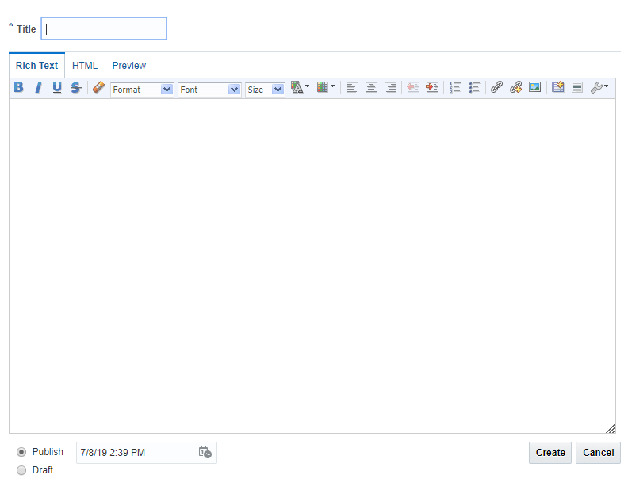

## Edit a Post

|  |  |
| --- | --- |
| Task name | Create a Post |
| Task owner | MOSA Intranet Blogger |
| Description | The blogger will edit a post in the blog. |
| Task preconditions | * The user logs on to the system. * The user is an Intranet blogger. * The post is exist in the posts list of the blog. |
| Input | The post. |
| Output | The post updated. |
| Task outcome | Edit Post (icon), Save, Cancel. |

|  |  |
| --- | --- |
| Task Main Flow | |
| # | **Actor action** | **System response** |
|  | Select “Edit Post” icon next to the post in the posts list at the blog page | The system will open the post in the post editor (Rich Text Editor). |
|  | Edit the title of this new post, edit the content of this blog (WYSIWYG mode or HTML mode), select if you want to re-publish the post or keep it as a draft then click “Save” | The system update the post. |

|  |  |
| --- | --- |
| Task exceptional Flow | |
| # | **Actor action** | **System response** |
|  | If the user select “Cancel” in any step | The new post will not be created. |

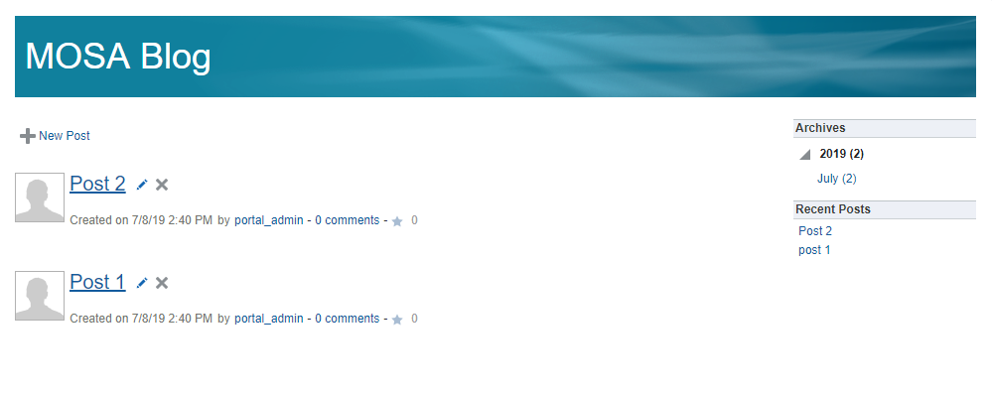

## Approve Blog Posts in Workflow

|  |  |
| --- | --- |
| Task name | Approve Blog Posts in Workflow |
| Task owner | MOSA Intranet Blogs Approver |
| Description | The approver will preview blog post and approve it. |
| Task preconditions | * The user logs on to the system. * The user is an Intranet Blogs approver. * The Blog post is in Blogs workflow. |
| Input |  |
| Output |  |
| Task outcome | Approve, Cancel. |

|  |  |
| --- | --- |
| Task Main Flow | |
| # | **Actor action** | **System response** |
|  | Click on blog post file name in “Content Management” page (Blogs tab) | The system will open the selected file in content previewer page. |
|  | Select “Approve” from the dropdown control “More” in the content previewer page | The system will prompt with the approve dialog. |
|  | Click “Approve” | The system will approve the Blog post and exist the workflow. |
|  | **Or** click “Approve” from the “Summary” tab in content previewer page. | The system will prompt with the approve dialog. |
|  | Click “Approve” | The system will approve the Blog post and exist the workflow. |

|  |  |
| --- | --- |
| Task exceptional Flow | |
| # | **Actor action** | **System response** |
|  | If the user select “Cancel” in any stage in the main flow | The dialog close. |

Alternative 1:

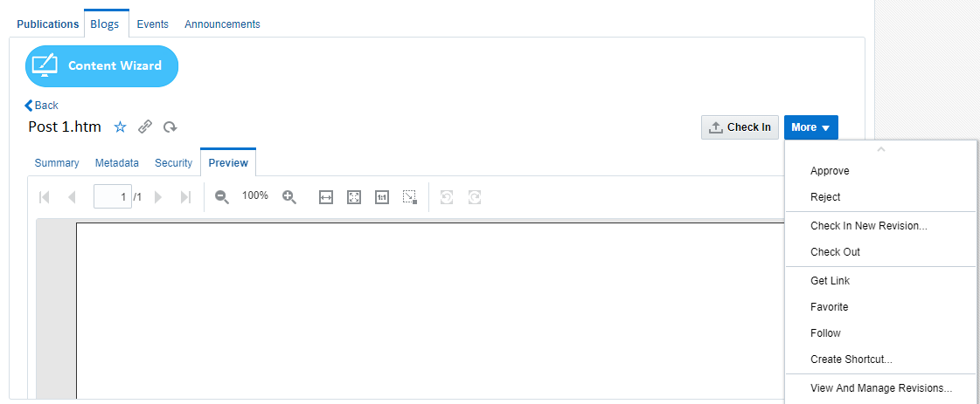

Alternative 2:

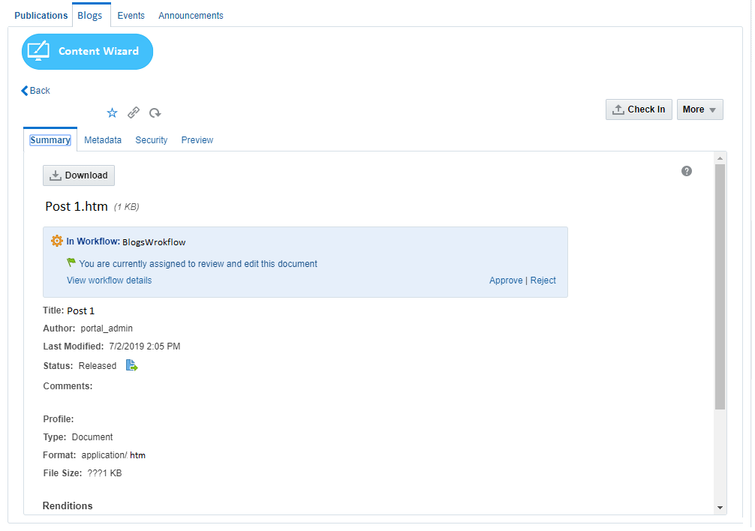

## Reject Blog Posts in Workflow

|  |  |
| --- | --- |
| Task name | Reject Blog Posts in Workflow |
| Task owner | MOSA Intranet Blogs Approver |
| Description | The approver will preview blog post and approve it. |
| Task preconditions | * The user logs on to the system. * The user is an Intranet Blogs approver. * The Blog post is in Blogs workflow. |
| Input |  |
| Output |  |
| Task outcome | Reject, Cancel. |

|  |  |
| --- | --- |
| Task Main Flow | |
| # | **Actor action** | **System response** |
|  | Click on Blog post name in “Content Management” page (Blogs tab) | The system will open the selected file in content previewer page. |
|  | Select “Reject” from the dropdown control “More” in the content previewer page | The system will prompt with the reject dialog. |
|  | Optionally, the approver adds the rejection reason inside the box “Reason for rejection” in the reject dialog | The system hold the text in this box. |
|  | Click “Reject” | The system will reject the Blog post and notify the content contributor (original blogger) by mail and notify him about this rejection including the rejection reason in this mail and return back to ‘contribution’ workflow step.  *Note: this is initial step in any content workflow, to exist from this step, a new revision of the content item must be checked-in so the content fall in workflow again.* |
|  | **Or** click “Reject” from the “Summary” tab in content previewer page | The system will prompt with the reject dialog. |
|  | Optionally, the approver adds the rejection reason inside the box “Reason for rejection” in the reject dialog | The system hold the text in this box. |
|  | Click “Reject” | The system will reject the Blog post and notify the content contributor by mail and notify him about this rejection including the rejection reason in this mail and return back to ‘contribution’ workflow step.  *Note: this is initial step in any content workflow, to exist from this step, a new revision of the content item must be checked-in so the content fall in workflow again.* |

|  |  |
| --- | --- |
| Task exceptional Flow | |
| # | **Actor action** | **System response** |
|  | If the user select “Cancel” in any stage in the main flow | The dialog close. |

Alternative 1:



Alternative 2:



Workflow

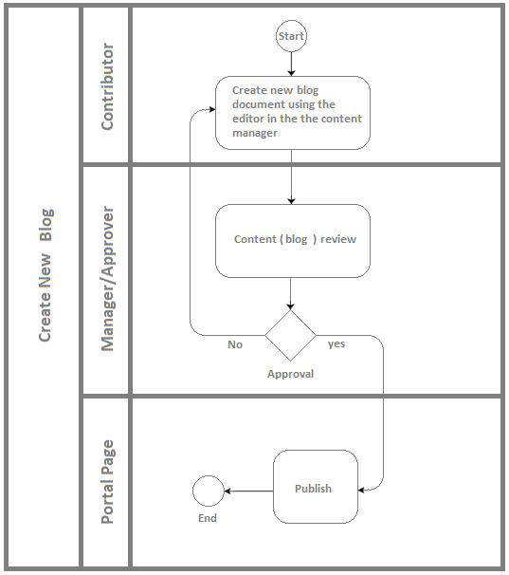

Developers & Contributors Tasks to Enable the Service

|  |  |  |
| --- | --- | --- |
| **Task** | **Application** | **Responsibility of** |
| Create a Page Using “Blogs” Page Style | Webcenter Portal | Content Contributor |
| Publish the Page for Users | Webcenter Portal | Content Contributor |

Updates Log