**functional requirements document**

|  |  |  |  |  |  |
| --- | --- | --- | --- | --- | --- |
| **Project Name** | : | MoSA Portal | **Date** | : | 01/Jul/2019 |
| **Requirement #** | : |  | **Created by** | : | Shakboua Zaid |

Requirement Title

Extranet - Announcements

Detailed Description

Announcements is used to inform extranet (public) users about opportunities at the ministry.

All announcements about the ministry will be added and verified in the content server through the portal. This type of content will be available for users from the main menu navigation and from a widget in the footer across all the pages.

A strip for announcements will be also available next to the slider at the “Home” page.

“Announcements” page provides the users with the ability to find MOSA announcements, it will be displayed as mini-view announcement item, which consist of a thumbnail image, a summary about the announcement, and the date of the announcement. The users will be also able to sort the announcements by date and name, as they will be able to search for announcements from this page.

“Announcements Detail” page show the actual announcement details, the system display full information about the announcement (all metadata).

Requirements

Announcements is a custom service, it represents a site studio element based on a content profile displayed in a content presenter at the portal.

**Announcements Profile Information Fields (Announcements Attributes)**:

|  |  |  |  |  |  |
| --- | --- | --- | --- | --- | --- |
| **Field** | **Caption** | **Required?** | **LOV?** | **Data Type** | **List** |
| dDocName | Content ID |  |  | Text |  |
| dDocType | Type |  |  | Text | * Application * Binary * DigitalMedia * Document * System * ServiceCard * Slide * News * **Announcement** * Event * Publication * Resource |
| dDocTitle | Title |  |  | Text |  |
| dDocAuthor | Author |  |  | Text | The list of all available users in the system.  Text entry is also applicable. |
| dSecurityGroup | Security Group |  |  | Text | * Public * Secure * PersonalSpaces * WebcenterSpaces * Intranet * **Extranet** |
| dRevLabel | Revision |  |  | Number |  |
| dInDate | Release Date |  |  | Date |  |
| primaryFile | Announcement File |  |  | File |  |
| summary | Announcement Summary |  |  | Plain Text Element Definition (Site Studio) |  |
| image | Announcement Image |  |  | Image Element Definition (Site Studio) |  |
| details | Announcement Details |  |  | WYSIWYG Element Definition (Site Studio) |  |

Use Cases

## Create New Announcement

|  |  |
| --- | --- |
| Task name | Create New Announcement |
| Task owner | MOSA Extranet Announcement Contributor |
| Description | The contributor will follow the steps at content creation wizard in order to add a new announcement. |
| Task preconditions | * The user logs on to the system. * The user is an Extranet Announcement contributor. |
| Input | The content creation wizard details and metadata. |
| Output | The content view mode editor. |
| Task outcome | Save and Close, Cancel. |

|  |  |
| --- | --- |
| Task Main Flow | |
| # | **Actor action** | **System response** |
|  | Click on “Content Wizard” link on the left top of the “Content Management” page (Announcements tab) | The system will open the content creation wizard in a new browser tab. |
|  | At the content creation wizard, the first step is to select the content type. Select “Announcements” from region definition drop down control and click “Next”. | The wizard will forward to the next step. |
|  | The next step is to select if you want to create new or update existing item then click “Next” | The wizard will forward to the next step. |
|  | Modify the default metadata if needed, or move to the last step by clicking “Finish” | The wizard will create the Announcement item and open it view edit mode. |
|  | At the view edit mode, insert the data in the specified areas (ex. insert summary text inside “Summary” area) then click “Save and Close” | The new Announcement item created and added to the repository |

|  |  |
| --- | --- |
| Task exceptional Flow | |
| # | **Actor action** | **System response** |
|  | If the user select “cancel” in any step before the last step (before clicking “Finish”) | The content creation wizard close without adding any new items. |
|  | If the user select “cancel” in any step after the last step (after clicking “Finish”) | The content creation wizard close and a new announcement item is initiated. |

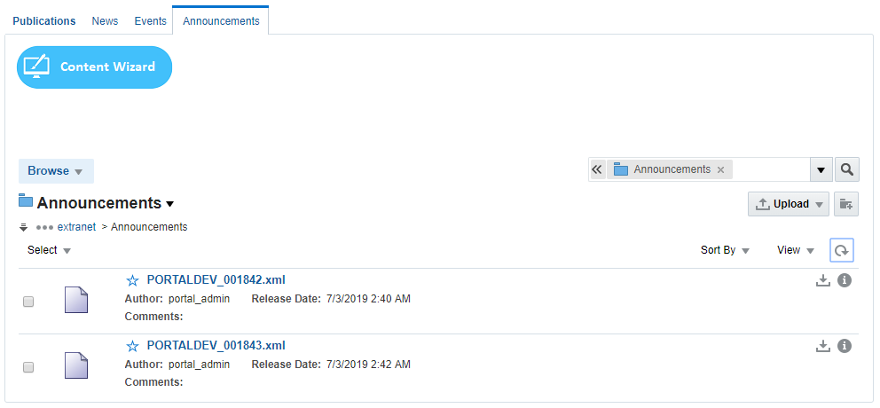

## Approve Announcement in Workflow

|  |  |
| --- | --- |
| Task name | Approve Announcements |
| Task owner | MOSA Extranet Announcement Approver |
| Description | The approver will preview Announcement file and approve it. |
| Task preconditions | * The user logs on to the system. * The user is an Extranet Announcement approver. * The Announcements item is in Announcements workflow. |
| Input |  |
| Output |  |
| Task outcome | Approve, Cancel. |

|  |  |
| --- | --- |
| Task Main Flow | |
| # | **Actor action** | **System response** |
|  | Click on Announcement file name in “Content Management” page (Announcements tab) | The system will open the selected file in content previewer page. |
|  | Select “Approve” from the dropdown control “More” in the content previewer page | The system will prompt with the approve dialog. |
|  | Click “Approve” | The system will approve the Announcement item and exist the workflow. |
|  | **Or** click “Approve” from the “Summary” tab in content previewer page. | The system will prompt with the approve dialog. |
|  | Click “Approve” | The system will approve the Announcement item and exist the workflow. |

|  |  |
| --- | --- |
| Task exceptional Flow | |
| # | **Actor action** | **System response** |
|  | If the user select “cancel” in any stage in the main flow | The dialog close. |

Alternative 1:

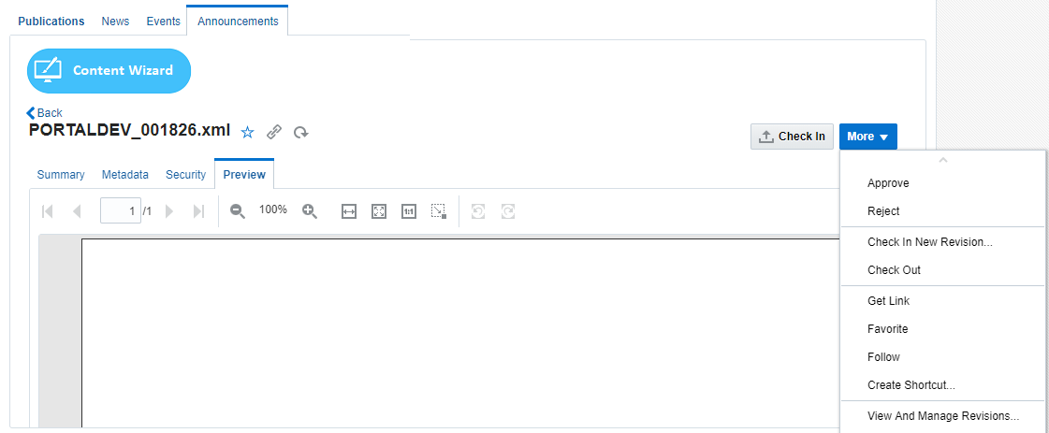

Alternative 2:

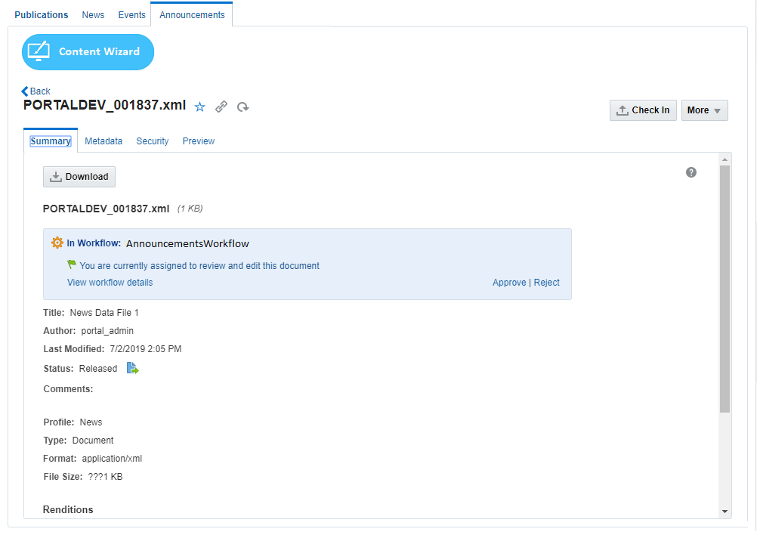

## Reject Announcement in Workflow

|  |  |
| --- | --- |
| Task name | Reject Announcement |
| Task owner | MOSA Extranet Announcement Approver |
| Description | The approver will preview Announcement file and reject it. |
| Task preconditions | * The user logs on to the system. * The user is an Extranet Announcement approver. * The Announcement item is in Announcements workflow. |
| Input |  |
| Output |  |
| Task outcome | Reject, Cancel. |

|  |  |
| --- | --- |
| Task Main Flow | |
| # | **Actor action** | **System response** |
|  | Click on Announcement file name in “Content Management” page (Announcements tab) | The system will open the selected file in content previewer page. |
|  | Select “Reject” from the dropdown control “More” in the content previewer page | The system will prompt with the reject dialog. |
|  | Optionally, the approver adds the rejection reason inside the box “Reason for rejection” in the reject dialog | The system hold the text in this box. |
|  | Click “Reject” | The system will reject the Announcement and notify the content contributor by mail and notify him about this rejection including the rejection reason in this mail and return back to ‘contribution’ workflow step.  *Note: this is initial step in any content workflow, to exist from this step, a new revision of the content item must be checked-in so the content fall in workflow again.* |
|  | **Or** click “Reject” from the “Summary” tab in content previewer page | The system will prompt with the reject dialog. |
|  | Optionally, the approver adds the rejection reason inside the box “Reason for rejection” in the reject dialog | The system hold the text in this box. |
|  | Click “Reject” | The system will reject the Announcement and notify the content contributor by mail and notify him about this rejection including the rejection reason in this mail and return back to ‘contribution’ workflow step.  *Note: this is initial step in any content workflow, to exist from this step, a new revision of the content item must be checked-in so the content fall in workflow again.* |

|  |  |
| --- | --- |
| Task exceptional Flow | |
| # | **Actor action** | **System response** |
|  | If the user select “cancel” in any stage in the main flow | The dialog close. |

Alternative 1:



Alternative 2:



## Update Announcement

|  |  |
| --- | --- |
| Task name | Update Announcement |
| Task owner | MOSA Extranet Announcement Contributor |
| Description | The contributor will select an Announcement item from the Announcements list in order to update its metadata. |
| Task preconditions | * The user logs on to the system. * The user is an Extranet Announcement contributor. * The file exist in Announcements folder. |
| Input | The Announcement update form details and data. |
| Output | The Announcement update form. |
| Task outcome | Update, reset. |

|  |  |
| --- | --- |
| Task Main Flow | |
| # | **Actor action** | **System response** |
|  | Click on Announcement file name in “Content Management” page (Announcements tab) | The system will open the selected file in “Content Previewer” page. |
|  | Click on “Edit” in “Content Previewer” page (Metadata tab) | The system will switch the form into edit mode. |
|  | Update the metadata as needed and click “Save” | The system stores the new updates. |

|  |  |
| --- | --- |
| Task exceptional Flow | |
| # | **Actor action** | **System response** |
|  | If the user select “cancel” in any stage during the update | The system will switch the form into read-only mode. |

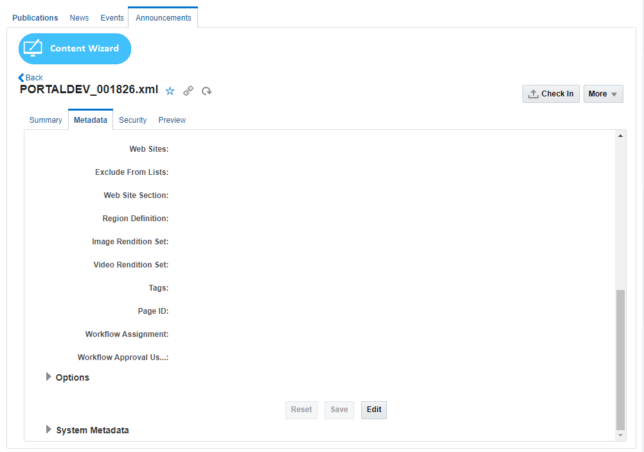

## Sort & Filter Announcements

|  |  |
| --- | --- |
| Task name | Sort & Filter Announcements |
| Task owner | MOSA Extranet User |
| Description | The user can sort Announcements by Announcements date or Announcements name. |
| Task preconditions |  |
| Input | Announcements list. |
| Output | Sorted Announcements list. |
| Task outcome | Sort. |

|  |  |
| --- | --- |
| Task Main Flow | |
| # | **Actor action** | **System response** |
|  | Click on “Sort by Date” from the top right of the Announcements list in “Announcements” page | The system will reorder the items in the Announcements list by Announcements date. |
|  | Click on “Sort by name” from the top right of the Announcements list in “Announcements” page | The system will reorder the items in the Announcements list by Announcements name. |

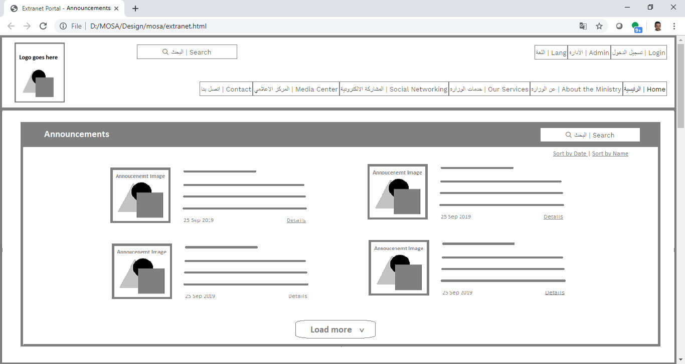

Workflow

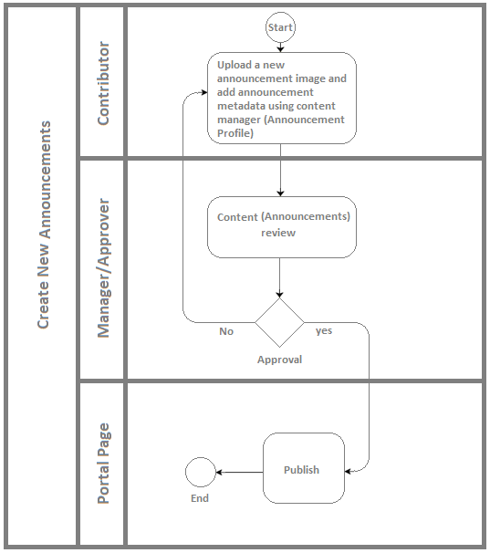

Developers & Contributors Tasks to Enable the Service

|  |  |  |
| --- | --- | --- |
| **Task** | **Application** | **Responsibility of** |
| Add Content Region Definition for Announcements | Site Studio | Content Administrator |
| Add Content Elements as Announcement Metadata | Site Studio | Content Administrator |
| Add Content Information Fields for Announcements | Webcenter Content | Content Administrator |
| Group Announcement Fields in Content Rule | Webcenter Content | Content Administrator |
| Create a Content Profile for Announcements Including the Content Rule | Webcenter Content | Content Administrator |
| Create a Content Presenter for Announcements | Webcenter Portal | Portal Administrator |
| Create a Page and Add the Content Presenter for Announcements | Webcenter Portal | Content Contributor |
| Publish the Page for Users | Webcenter Portal | Content Contributor |

Updates Log