

**MOSA Price Monitoring Module**

**Software Requirements Specification (SRS)**

|  |  |  |
| --- | --- | --- |
| شعار ملونDocument Details | | |
| Document Owner | Doc No | Document Type |
| AL DAR | MOSA Price Monitoring SRS –1.0 | SRS |
|  |  |  |

**Revision History**

|  |  |  |  |
| --- | --- | --- | --- |
| **Approvals** | | | |
| **Name** | **Title** | **Date** | **Signature** |
|  |  |  |  |
|  |  |  |  |

|  |  |  |  |
| --- | --- | --- | --- |
| **Changes Records** | | | |
| **Date** | **Author** | **Version** | **Change Reference** |
| 25/11/2018 | Osama Zgool | 1.0 |  |
| 26/11/2018 | Saad Jaradat | 1.0 | Review Changes |
| 25/12/2018 | Osama Al Zgool | 1.1 | MOSA IT Team Review |

# Acceptance History

|  |  |  |  |  |
| --- | --- | --- | --- | --- |
| # | Name | Department | Date | Signature |
|  |  |  |  |  |
|  |  |  |  |  |
|  |  |  |  |  |
|  |  |  |  |  |

Contents

Acceptance History 2

1 Introduction 8

1.1 Product Overview 8

1.2 Intended Audience 8

1.3 Terms and Abbreviations 8

1.3.1 Terms 8

1.3.2 Abbreviations 9

2 Price Comparison Screens (مقارنة الاسعار) 10

2.1 Description 10

2.2 Process identification card 10

2.3 Process preconditions 10

2.4 Process input 10

2.5 Process output 10

2.6 Process model 11

2.7 Functional requirements 11

2.8 Use Cases 12

2.8.1 Price Comparison and Send Items to Inspection Table 12

2.8.2 Task screens and fields 14

3 Price Monitoring Screens (مراقبة الاسعار) 17

3.1 Description 17

3.2 Process identification card 17

3.3 Process preconditions 17

3.4 Process input 18

3.5 Process output 18

3.6 Process model 18

3.7 Functional requirements 18

3.8 Use Cases 19

3.8.1 Item Price Monitoring Actions 19

4 Item General Details (معلومات عامة لسلعة) 27

4.1 Description 27

4.2 Process identification card 27

4.3 Process preconditions 27

4.4 Process input 27

4.5 Process output 27

4.6 Process model 28

4.7 Functional requirements 28

4.8 Use Cases 29

4.8.1 Get General Information about Specific Item 29

4.8.2 Task screens and fields 31

5 Item Price Change within Period (مراقبة سعر سلعة خلال مده زمنية) 34

5.1 Description 34

5.2 Process identification card 34

5.3 Process preconditions 34

5.4 Process input 34

5.5 Process output 34

5.6 Process model 35

5.7 Functional requirements 35

5.8 Use Cases 35

5.8.1 Item Price Change within period of time 35

5.8.2 Task screens and fields 37

6 Item / Category Price Average within Period (متوسط سعر قسم/ سلعة خلال مدة زمنية) 42

6.1 Description 42

6.2 Process identification card 42

6.3 Process preconditions 42

6.4 Process input 42

6.5 Process output 42

6.6 Process model 43

6.7 Functional requirements 43

6.8 Use Cases 43

6.8.1 Item Price Average within period 43

6.8.2 Defined Category Price Average within Period 45

6.8.3 Task screens and fields 46

7 Add Category Screen (اضافة قسم) 50

7.1 Description 50

7.2 Screen identification card 50

7.3 Screen output 50

7.4 Functional requirements 50

7.5 Use Cases 51

7.5.1 Add, Edit, Delete Category 51

7.5.2 Task screens and fields 53

8 Profit Margin Screen (هوامش الربح) 55

8.1 Description 55

8.2 Screen identification card 55

8.3 Screen output 55

8.4 Functional requirements 55

8.5 Use Cases 56

8.5.1 Create, Edit Delete Profit Margin 56

8.5.2 Task screens and fields 58

9 Manage Defined Items Screen (ادارة السلع المعرفة) 60

9.1 Description 60

9.2 Screen identification card 60

9.3 Screen output 60

9.4 Functional requirements 60

9.5 Use Cases 61

9.5.1 Define Items 61

9.5.2 Link Cooperatives items 63

9.5.3 Link items with a supplier from Add and link Items screen 65

9.5.4 Task screens and fields 66

10 Manage Defined Providers Screen (ادارة الموردين المعرفين) 71

10.1 Description 71

10.2 Screen identification card 71

10.3 Screen output 71

10.4 Functional requirements 71

10.5 Use Cases 73

10.5.1 Define providers 73

10.5.2 Define Items 75

10.5.3 Link Cooperatives items 77

10.5.4 Task screens and fields 79

11 Manual Comparison Tables Screens (جداول المقارنة اليدوية) 85

11.1 Description 85

11.2 Screen identification card 85

11.3 Screen output 85

11.4 Functional requirements 85

11.5 Use Cases 86

11.5.1 Define Comparisons Tables 86

11.5.2 Add Cooperatives Items to Comparison Table 88

11.5.3 Task screens and fields 90

12 Item Price Inspection Orders (طلبات تفتيش السلع) 94

12.1 Description 94

12.2 Screen identification card 94

12.3 Screen output 94

12.4 Functional requirements 94

12.5 Use Cases 95

12.5.1 Add and Delete Items from Inspection Table. 95

12.5.2 Send Price Inspection Orders for Cooperatives 98

12.5.3 Task screens and fields 99

13 Item Details Screen (تفاصيل السلعة) 102

13.1 Description 102

13.2 Screen identification card 102

13.3 Screen output 102

13.4 Functional requirements 102

13.5 Use Cases 102

13.5.1 Display Item Details 102

13.5.2 Task screens and fields 103

14 Upload CSV File (Cooperatives Screen) (تحميل بيانات الجمعية) 106

14.1 Description 106

14.2 Screen identification card 106

14.3 Screen output 106

14.4 Functional requirements 106

14.5 Use Cases 106

14.5.1 Upload CSV File 106

14.5.2 Task screens and fields 107

15 CSV File Upload Status (حالة تحميل البيانات من قبل الجمعيات) 109

15.1 Description 109

15.2 Screen identification card 109

15.3 Screen output 109

15.4 Functional requirements 109

15.5 Use Cases 109

15.5.1 Search for CSV File Upload Status 109

15.5.2 Task screens and fields 111

16 Reports (التقارير) 113

17 Appendices 114

17.1 Forms and reports 114

# Introduction

## Product Overview

CO-OPs needed to automate the Processes of Price Monitoring on all cooperative’s super markets, to reduce the employee’s effort, protect the customers of all cooperative’s super markets, quickly capture all cooperative’s super markets contrary to law and to get useful reports helps the ministry in future decisions.

This Document describe in details the automation solution for price monitoring system, based on the previous Requirements have been gathered from the ministry side and highlighted in the business requirement document for Price Monitoring Module and below is the summery of the business functions:

1. The user will be able to compare similar Items prices details for different cooperatives.
2. The user will be able to search and monitor any item in any cooperative with various available search options.
3. The user will get general information about specific item (Highest/lowest selling price, number of providers, quantity available … etc.).
4. The user can manually create comparison tables for targeted items.
5. The user can track the price change for item within period in a cooperative.
6. The user can get the price average within period.
7. The user can define new categories to categorize targeted items.
8. The user can create a profit margin percentage for commodity group.
9. The user can manually link items that do not have a similar specs in different cooperatives.
10. The user can manually link items with a defined supplier.
11. The user can send items to be inspected.
12. The user can display all the required details for any item.
13. The user can track uploading csv file status for all cooperatives.
14. The cooperatives users can upload CSV file on the system.

## Intended Audience

This document is intended for both MOSA IT Technical team and Al Dar both top management and technical team.

## Terms and Abbreviations

### Terms

|  |  |  |
| --- | --- | --- |
| # | Item | Description |
|  | Cooperatives Item | Item in specific cooperative |
|  | CSV file | File with extension .csv |
|  | Cooperative user | User Account defined in the system for a responsible person in a cooperative. |
|  | Defined item | Item created in the system by the user used to link items from different cooperatives |
|  | Defined Provider | Provider created in the system by the user used to link items from different cooperatives to a specific supplier. |

### Abbreviations

|  |  |  |
| --- | --- | --- |
| # | Item | Description |
|  | MOSA | Ministry of Social Affairs |
|  | DB | Database |
|  |  |  |
|  |  |  |

# Price Comparison Screens (مقارنة الاسعار)

## Description

The comparison screen will let the user compare the items prices that has been defined by the user, compare items added from the union with the cooperative’s items have the same barcode and let the user to send inspections orders for specific cooperatives using the following search criteria:

1. Search by Barcode: The system display the Item has the barcode inserted.
2. Search by Item Name: The system will display all items related or close to the inserted text.

And the following Filters:

1. City: The system will display all cooperatives related to the city selected.
2. Category: Category already defined in add category screen, the system will display all items related to the category selected.
3. Cooperatives Selection: The user could determine the selected cooperatives for Search or filtered result on items.
4. Items select list: the list of Items that are manually Identified by the user and mapped to specific item in each cooperative in add items screen and the union items.

## Process identification card

|  |  |
| --- | --- |
| Process ID | PM - PM001 |
| Process name | Price Comparison. |
| Process purpose | Compare items prices from different cooperatives and send inspection orders for specific cooperatives. |
| Initiator user | Inspections Department users. |
| Process owner | The admin of this process |
| Process type | Main Process |

## Process preconditions

.CSV file uploaded on CO-OPs System.

## Process input

.CSV file uploaded on CO-OPs system.

## Process output

The user will be able to compare items from different Cooperatives and send inspections orders for specific cooperatives.

## Process model

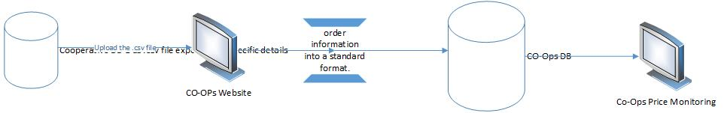

## Functional requirements

List of the functional requirements:

|  |  |  |  |
| --- | --- | --- | --- |
| REQ # | Requirement | Description | Notes |
| FR – PM - 001 | Search on cooperatives by City | The user selects a city, all cooperatives in the selected city should be included in the item search result and the user will be able to exclude or add more cooperatives. |  |
|  | Search on items by category that already identified and mapped | All items related to the selected category that already identified and mapped in add items screen should be displayed, based on the cooperative selected. |  |
|  | Search on items related to specific provider already identified. | All items related to the provider identified and mapped in add provider screen should be displayed, also the category and the items should be filtered based on the selected provider. |  |
|  | Search on items by barcode | The user can insert the item barcode to display the items details result for the selected cooperatives. |  |
|  | Search on items by Items Names | The user can insert the item name to display all related results for the selected cooperatives. |  |
|  | Search for items in specific cooperatives | The user can target items based on the cooperative’s selection. |  |
|  | Select Items Identified and mapped | A select list that have all Items identified and mapped for specific item in each cooperative by the user in add items screen. |  |
|  | Results display in table | the result for the search will display in a table and the table will have:   1. Item name 2. Measuring Unit 3. Provenance 4. Lowest selling price between all selected cooperatives for the targeted items. 5. Item Selling price. 6. Cooperative Name. |  |
|  | Results of the search should be based on specific date | Result for the searched Items should display based on the date inserted by the user. |  |
|  | Add Items to Inspection table | The user can mark specific Items to add it to the Items inspection table by clicking on Add to Inspection Table button. |  |

## Use Cases

### Price Comparison and Send Items to Inspection Table

|  |  |
| --- | --- |
| Use Case ID | PM -UC01 |
| Use Case Name | Price Comparison |
| Actors | Privileged users |
| Description | Compare items prices between selected cooperatives that manually mapped by the user or by automatic mapping using union items barcodes. |
| Preconditions | .CSV file uploaded to CO-OPs system for the selected date. |
| Post conditions | The user can compare the cooperatives items prices with the union items prices for the items have been provided by union, the user can also compare the items have been manually mapped and send specific items to the inspection table. |
| Business rules | 1. Union item price should display for the user for the items have prices from the union. 2. Results for the items should be displayed based on the search criteria inserted by the user. 3. Date should be inserted. 4. The user can not add the same items for the same cooperative to inspection table twice with the same date. 5. Each Item sent to the inspection table should be classified to specific cooperative. |

**Main Flow**

|  |  |  |
| --- | --- | --- |
| # | Actor Action | System Response |
| 1 | The privileged user navigates to price Comparison screen. | Price comparison screen displayed and all fields with the default value. |
| 2 | The user select the cooperatives targeted for comparison by selecting the city from select list or randomly cooperatives from shuttle field. | If a city selected all cooperatives in the selected city will be targeted for the search and the user able to add more cooperatives. If cooperatives selected from the shuttle field, the city select list will be disabled. |
| 3 | The user selects the category which the items belong to and the option to select all category is available. | Category selected. (optional step) |
| 4 | The user can select specific item or all items. | Items selected. (optional step) |
| 5 | The user selects a provider. | All categories and items are filtered to the selected provider. (Optional step) |
| 6 | The user insert the date for the targeted search. | Items details result should be displayed based on the selected date. |
| 7 | The user clicks on search button. | Results display in the table as it is described here. |
| 8 | Based on the result the user can select items to be added to the inspection table. | Items selected and user click on add to inspection table to send the items to inspection table. |

**Alternative Flows**

|  |  |  |
| --- | --- | --- |
| # | Actor Action | System Response |
| 1 | The user selects the cooperatives targeted for the search. | Cooperatives selected. |
| 2 | The user inserts the item barcode. | Category list, item list, search box should be disabled. |
| 3 | The user insert the date for the search. | Items details result should be displayed based on the date selected. |
| 4 | The user clicks on search button. | Item details displayed in the table. |
| Second flow | | |
| 1 | The user selects the cooperatives targeted for the search. | Cooperatives selected. |
| 2 | The user inserts the item name in search box. | Category list, item list, barcode text box should be disabled. |
| 3 | The user inserts the date for the search. | Items details result should be displayed based on the date selected. |
| 4 | The user clicks on search button. | Items related details displayed in the table. |
| Third flow | | |
| 1 | The user selects the cooperatives targeted for the search. | Cooperatives selected. |
| 2 | The user inserts the search date. | Date inserted. |
| 3 | The user clicks on search button. | Items details displayed in the table. |
|  |  |  |

**Exceptional Flows**

|  |  |  |
| --- | --- | --- |
| # | Actor Action | System Response |
| 1 | The user does not select the cooperatives targeted for the search. | Cooperatives selected. |
| 2 | The user inserts the search date. | Date inserted. |
| 3 | The user clicks on search button. | No Search result will display. |
|  |  |  |
|  |  |  |

**System Messages:**

|  |  |  |  |
| --- | --- | --- | --- |
| # | Actor Action | Message Type | System Response |
| 1 | The user does not select the cooperatives targeted for the search and click on search button. | Error Message | يرجى اختيار الجمعيات |
| 2 | The user does not insert the search date and click on search button. | Error Message | يرجى ادخال التاريخ |
| 3 | The user clicks on search button without insert any field. | Error Message | يرجى ادخال الحقول الالزاميه |
| 4 | The user insert data that does not display any search result. | Error Message | لا يوجد نتائج للبحث |
| 5 | The user Click on send to inspection table without selecting any Item | Error Message | يرجى اختيار السلع اللتي ترغب بارسالها لجدول التفتيش المباشر |
| 6 | The user select items that are already in inspection table and click on send to inspection table. | Error Message | لم يتم ارسال السلع الى جدول التفتيش المباشر السلع التاليه موجوده بالفعل في جدول التفتيش المباشر  (مع ذكر اسماء السلع) |
| 7 | The user select Items that are not mapped and click on search button. | Error Message in the table for each item that is not mapped with the cooperative. | لم يتم ربط السلعه مع الجمعيه المختاره |
| 8 | Missed detail for Item displayed in the table after search. | Error Message for each column | لم يتم تزويد المعلومات من قبل الجمعيه |
| 9 | The user select items and clicked on send to inspection table | Hint Message | تم ارسال السلع الى جدول التفتيش المباشر |

### Task screens and fields

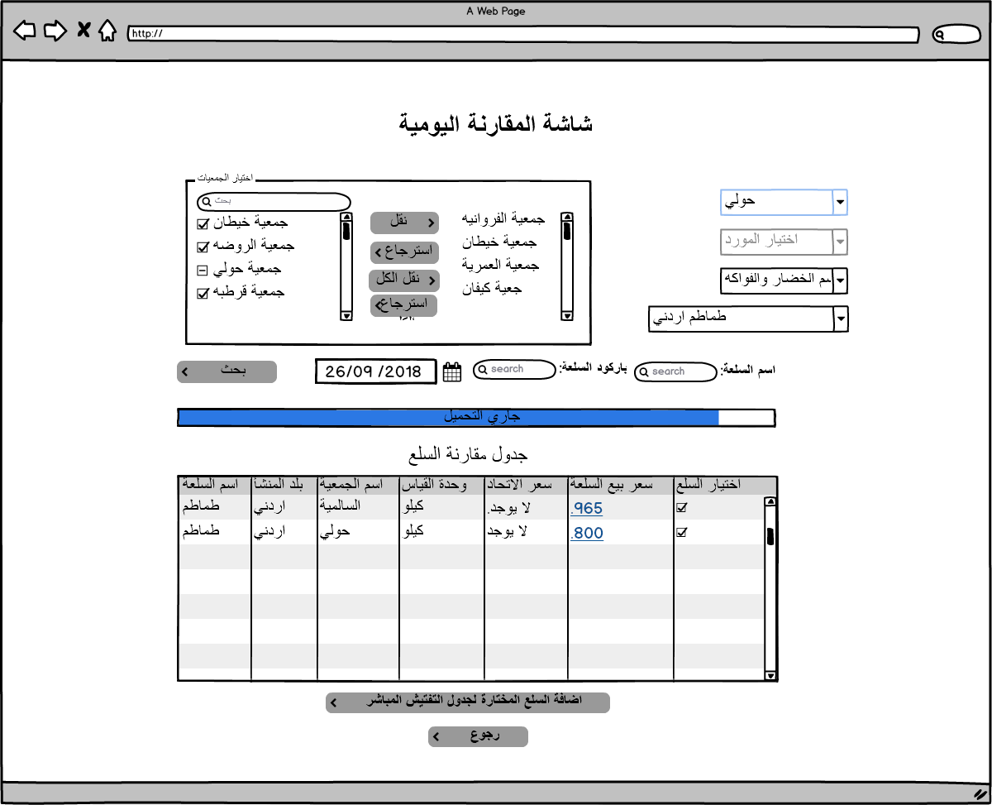

|  |  |  |  |  |  |  |
| --- | --- | --- | --- | --- | --- | --- |
| Price Comparison Mockups Fields Description | | | | | | |
| Field | Description | Type | Default value | Mandatory | Length | Notes |
| Cooperatives selection | Contain all cooperatives and the user can select the targeted cooperatives | Shutter field | Non-selected | Mandatory | N/A | Could be changed to popup and the user can mark the targeted cooperatives DB : MOSA_PORTAL_ENTITIES.PROFILE_NO_REF |
| Supplier list | Contain all defined suppliers have mapped items | Drop down list | Non-selected | Optional | N/A | DB : PMON_SUPPLIER.SUPPLIER_DESC_AR |
| City list | Contains all cooperatives in the city. | Drop down list | Non-Selected | Optional | N/A | 1. the user can select a city and add more or remove cooperatives  2.Could be changed to popup has a table with the same details DB : LOV.LOV_ID(PARENT_LOV_ID=12) |
| Category list | Category list will display already added categories in add category screen. | Drop down list | Non-Selected | Optional | N/A | DB:  PMON_ITEM_SECTIONS. SECTION_NAME_AR |
| Subcategory list | Category list will display already added categories in add category screen. | Drop down list | Non-Selected | Optional | N/A | PMON_ITEM_SECTIONS_DETALS. MSTR_SECTION_NAME_AR |
| Item list | To select items that already added and mapped in add item screen. | Drop down list | Non-Selected | Optional | N/A | Could be changed to popup has a table with the same details DB:  PMON_GENERAL_ITEMS. ITEM_DESC_AR |
| Item Name Search | To insert the item name targeted for search | Text field | Empty | Optional | 50 | Cooperatives or city selection becomes mandatory to be target specific cooperatives. DB:  PMON_GENERAL_ITEMS. ITEM_DESC_AR PMON_GENERAL_ITEMS. ITEM_DESC_EN |
| Barcode Search | To insert the barcode number for the targeted item. | Text field | Empty | Optional | 20 | Cooperatives or city selection becomes mandatory to be target specific cooperatives. DB:  PMON_GENERAL_ITEMS. ITEM_UNIV_BARCODE |
| Date of comparison | To insert the date of comparison and to get the Item details as per the date inserted. | Date | System Date | Mandatory | N/A |  |
| Search Action | To Get the result based on the inserted search criteria. | Button | Disabled | Mandatory | N/A | Button becomes enabled once the user inserts a correct search criteria. |
| Add to inspection table | To send the selected items to inspection table | Button | Enabled | Mandatory | N/A | Items add and classified in inspection details screen. DB: INSP_PRICE_INSPECTION |
| Back Button | To Back to Home Page of the price Monitoring | Button | Enabled | Mandatory | N/A |  |
| Search Result Table | | | | | | |
| Item Name | **Provenance** | **Cooperative Name** | **Measuring Unit** | **Union item price** | **Item Selling Price** | 1. Item Selling price result should be as a link redirect the user to Item Details screen. That will be described in item details screen.  2. Union Selling price result should be as a link redirect the user to union Item Details screen. That will be described in union item details screen. 3. a mark box should be displayed for each row to let the user mark one or multiple items |
| DB details PMON_GENERAL_ITEMS | | | | | | |
| PMON_GENERAL_ITEMS.ITEM_DESC_AR or PMON_GENERAL_ITEMS.ITEM_DESC_EN | PMON_UNION_RAWDATA.CountryOfOrigin | PMON_DET_RAWDATA.RAWDATA_MSTR_COOP_ID | PMON_UNION_RAWDATA.MEASURING_UNIT | PMON_UNION_RAWDATA. ITEM_COST_PRICE | PMON_DET_RAWDATA. RAWDATA_CSV_ITEM_SELL_PRICE |  |

# Price Monitoring Screens (مراقبة الاسعار)

## Description

The Monitoring screen will let the user monitor the items that exist in CO-OPs database, Map Items, build Comparison Items table manually and save it for later use, send inspection orders, Edit Profit Margin and using the following search criteria:

1. Search by Barcode: The system display the Item has the barcode inserted.
2. Search by Item Name: The system will display all items related or close to the inserted text.

And the following Filters:

1. City: The system will display all cooperatives related to the city selected and the user is able to add more cooperative.
2. Category: The system will display all items related to the category selected.
3. Cooperatives Selection: The user could determine the selected cooperatives for Search or filtered result on items.
4. Supplier: The system will display all the items that have been supplied by the supplier, if the supplier have similar specs in different cooperative.

And the following Search option:

1. Normal search will display all items based on the search criteria inserted.

Profit Margin Search will display all items selling with profit margin more than the expected based on MOSA Law.

## Process identification card

|  |  |
| --- | --- |
| Process ID | PM - PM002 |
| Process name | Price Monitoring. |
| Process purpose | Monitor items prices from different cooperatives. |
| Initiator user | Inspections Department users. |
| Process owner | The admin of this process |
| Process type | Main Process |

## Process preconditions

.CSV file uploaded on CO-OPs System.

## Process input

.CSV file uploaded on CO-OPs system.

## Process output

The user will be able to Monitor items for different Cooperatives and send inspection orders.

## Process model



## Functional requirements

List of the functional requirements:

|  |  |  |  |
| --- | --- | --- | --- |
| REQ # | Requirement | Description | Notes |
| FR – PM - 001 | Search on cooperatives by City | The user selects a city, all cooperatives in the selected city should be included in the item search result. |  |
|  | Search on items by category | All items related to the selected category should be displayed. |  |
|  | Search on Items by Supplier | All Items supplied by the supplier should be displayed. |  |
|  | Search on items by barcode | The user can insert the item barcode to display the items details result for the selected cooperatives. |  |
|  | Search on items by Items Names | The user can insert the item name to display all related results for the selected cooperatives. |  |
|  | Search for items in specific cooperatives | The user can target items based on the cooperative’s selection. |  |
|  | Results display in table | the result for the search will display in a table and the table will have the following column:   1. Item name. 2. Measuring Unit. 3. Supplier Name 4. Provenance 5. Quantity per unit 6. Quantity per package 7. Bill Number 8. Receiving Receipt Number 9. Selling Price per Item 10. Selling Price per Package 11. Buying Price per Item 12. Buying Price per Package 13. Date of receiving Item 14. Category 15. Item Barcode |  |
|  | Results of the search should be based on specific date | Result for the searched Items should display based on the date inserted by the user. |  |
|  | The user can build manual comparison table. | The user can select specific items and add them to the manual comparison table to be compared as per the end user point of view. |  |
|  | The user can save the comparison table for later use. | The user can save the table created in Manual comparison table’s screen for later use. |  |
|  | Edit profit margin related to MOSA law. | The user can edit or add profit margin for specific item or for group of items. |  |
|  | Map Selected Items to General Item already defined. | From price monitoring screen the user can link items from different cooperatives to general item already defined. |  |
|  | Map selected to Provider already defined | From price monitoring screen the user can link items from different cooperatives to provider already defined. |  |
|  | Add Items to the inspection table. | The user can mark multiple items and add them to the inspection table. |  |

## Use Cases

### Item Price Monitoring Actions

|  |  |
| --- | --- |
| Use Case ID | PM -UC02 |
| Use Case Name | Item Price Monitoring Actions |
| Actors | Privileged users |
| Description | 1. Monitor selected items prices and details between selected cooperatives. 2. Make comparisons tables for items. 3. Link item with defined item 4. Link Item with provider. 5. Send item to inspection table. 6. Edit profit Margin. |
| Preconditions | .CSV file uploaded to CO-OPs system for the selected date. |
| Post conditions | Profit Margin related to MOSA law could be added or edited, the user can map items to general Item or to provider, the user can add items to the inspection table, the user can manually build a comparison table and save it for later use. |
| Business rules | 1. Results for the items should be displayed based on the search criteria inserted by the user. 2. Date should be inserted. 3. The user can not add the same items for the same cooperative to inspection table twice with the same date. 4. Each Item sent to the inspection table should be classified to specific cooperative. |

**Main Flow**

|  |  |  |
| --- | --- | --- |
| # | Actor Action | System Response |
| 1 | The privileged user navigates to price monitoring screen. | Price monitoring screen displayed and all fields with the default value. |
| 2 | The user select the cooperatives targeted for Monitoring by selecting the city from select list or randomly cooperatives from shuttle field. | If a city selected all cooperatives in the selected city will be targeted for the search. If cooperatives selected from the shuttle field, the city select list will be disabled. |
| 3 | The user selects the category which the items belong to and the option to select all category is available. | Category selected. (optional step) |
| 4 | The user can select specific item or all items. | Items selected. (optional step) |
| 5 | The user selects the provider or all providers. | All items related to the selected provider should be included in the search (optional step) |
| 6 | The user clicks on search button. | Results display in the table as it is described here. |
| Search for items with selling price more than the expected based on MOSA law | | |
| 1 | The privileged user navigates to price monitoring screen. | Price monitoring screen displayed and all fields with the default value. |
| 2 | The user select the cooperatives targeted for Monitoring by selecting the city from select list or randomly cooperatives from shuttle field. | If a city selected all cooperatives in the selected city will be targeted for the search. If cooperatives selected from the shuttle field, the city select list will be disabled. |
| 3 | The user selects the category which the items belong to and the option to select all category is available. | Category selected. (optional step) |
| 4 | The user can select specific item or all items. | Items selected. (optional step) |
| 5 | The user selects the provider or all providers. | All items related to the selected provider should be included in the search (optional step) |
|  | The user clicks on search for items with invalid profit margin button. | Items have invalid selling price as per MOSA profit margin expected will display in price Monitoring table. |
|  |  |  |

**Alternative Flows**

|  |  |  |
| --- | --- | --- |
| # | Actor Action | System Response |
| 1 | The user selects the cooperatives targeted for the search. | Cooperatives selected. |
| 2 | The user inserts the item barcode. | Category list, item list, search box should be disabled. |
| 3 | The user inserts the date for the search. | Date inserted. |
| 4 | The user clicks on search button. | Item details displayed in the table. |
| Second flow | | |
| 1 | The user selects the cooperatives targeted for the search. | Cooperatives selected. |
| 2 | The user inserts the item name in search box. | Category list, item list, barcode text box should be disabled. |
| 3 | The user inserts the date for the search. | Date inserted. |
| 4 | The user clicks on search button. | Items related details displayed in the table. |

**Exceptional Flows**

|  |  |  |
| --- | --- | --- |
| # | Actor Action | System Response |
| 1 | The user selects the cooperatives targeted for the search. | Cooperatives selected. |
| 2 | The user inserts the search date. | Date inserted. |
| 3 | The user clicks on search button. | Items details displayed in the table. |
| Second Flow | | |
| 1 | The user select one or multiple Items that displayed based on any search result mentioned in the above flows. | Items selected. |
| 2 | The user click on add to comparison table | Items selected added to the comparison table. |
| 3 | The user can save the created table by clicking on save button. | Create manual popup table will be displayed and the user can insert a name and description for the table and will be saved in manual comparison tables screen as it is described her (Manual comparison tables screen). |
| Third flow | | |
| 1 | The user select one or multiple Items that displayed based on any search result mentioned in the above flows. | Items selected. |
| 2 | User click on Edit profit margin button | User select profit margin category from the list already identified in add profit margin screen. |
| 3 | User click on save button. | All items selected will have the new profit margin selected. |

**System Messages:**

|  |  |  |  |
| --- | --- | --- | --- |
| # | Actor Action | Message Type | System Response |
| 1 | The user does not select the cooperatives targeted for the search and click on search button. | Error Message | يرجى اختيار الجمعيات |
| 2 | The user does not insert the search date and click on search button. | Error Message | يرجى ادخال التاريخ |
| 3 | The user clicks on search button without insert any field. | Error Message | يرجى ادخال الحقول الالزاميه |
| 4 | The user insert data that does not display any search result. | Error Message | لا يوجد نتائج للبحث |
| 5 | The user Click on send to inspection table without selecting any Item | Error Message | يرجى اختيار السلع اللتي ترغب بارسالها لجدول التفتيش المباشر |
| 6 | The user select items that are already in inspection table and click on send to inspection table. | Error Message | لم يتم ارسال السلع الى جدول التفتيش المباشر السلع التاليه موجوده بالفعل في جدول التفتيش المباشر  (مع ذكر اسماء السلع) |
| 7 | The user select Items that are not mapped and click on search button. | Error Message in the table for each item that is not mapped with the cooperative. | لم يتم ربط السلعه مع الجمعيه المختاره |
| 8 | Missed detail for Item displayed in the table after search. | Error Message for each column | لم يتم تزويد المعلومات من قبل الجمعيه |
| 9 | The user select items and clicked on send to inspection table | Hint Message | تم ارسال السلع الى جدول التفتيش المباشر |

#### Task screens and fields

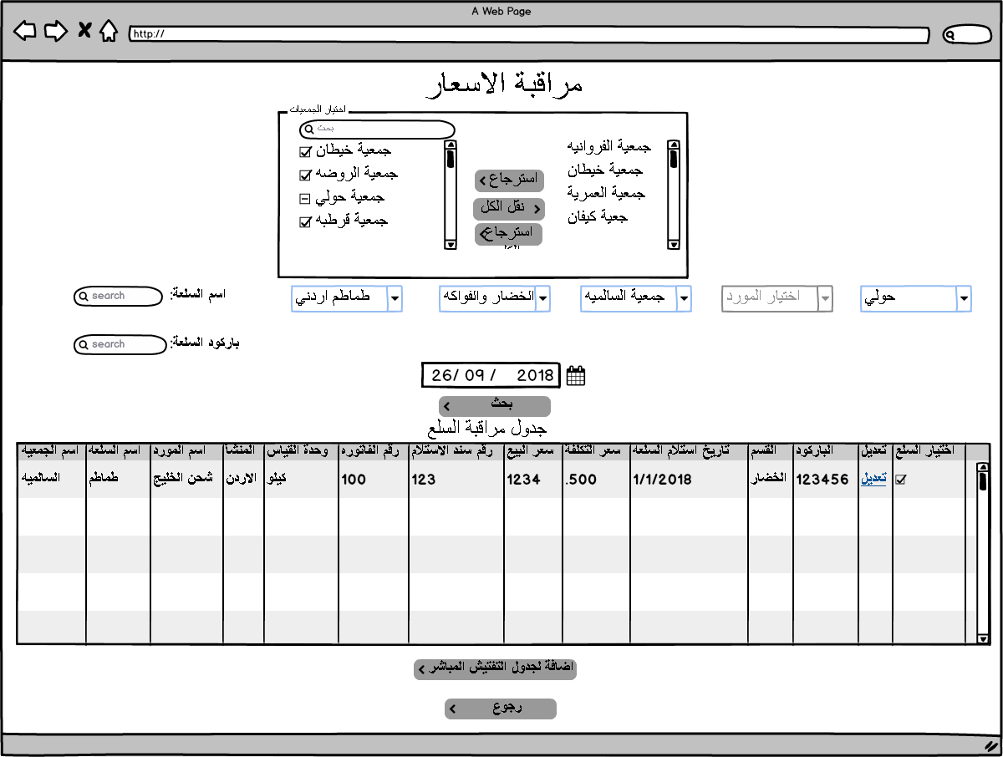

|  |  |  |  |  |  |  |  |  |
| --- | --- | --- | --- | --- | --- | --- | --- | --- |
| Price Monitoring Mockups Fields Description | | | | | | | | |
| Field | Description | | Type | Default value | Mandatory | | Length | Notes |
| Cooperatives selection | Contain all cooperatives and the user can select the targeted cooperatives | | Shutter field | Non-selected | Mandatory | | N/A | Could be changed to popup table and the user can mark the targeted cooperatives. This field becomes mandatory if the city is not selected.  DB:  MOSA_PORTAL_ENTITIES.PROFILE_NO_REF |
| City list | Contains all cooperatives in the city. | | Drop down list | Non-Selected | Optional | | N/A | Could be changed to popup have a table with all cities. DB:  LOV.LOV_ID(PARENT_LOV_ID=12) |
| Category list | To select targeted category. | | Drop down list | Non-Selected | Optional | | N/A | Could be changed to popup or faster solution DB:  PMON_DET_RAWDATA.RAWDATA_CSV_ITEM_CATEGORY |
| Item list | To select targeted Item. | | Drop down list | Non-Selected | Optional | | N/A | Could be changed to popup or faster solution DB:  PMON_DET_RAWDATA.RAWDATA_CSV_ITEM_NAME_AR |
| Item Name Search | To insert the item name targeted for search | | Text field | Empty | Optional | | 50 | Cooperatives or city selection becomes mandatory to be target specific cooperatives. |
| Barcode Search | To insert the barcode number for the targeted item. | | Text field | Empty | Optional | | 20 | Cooperatives or city selection becomes mandatory to be target specific cooperatives. |
| Date of Monitoring | To insert the date of monitoring and to get the Item details as per the date inserted. | | Date | System Date | Mandatory | | N/A |  |
| Search Action | To Get the result based on the inserted search criteria. | | Button | Disabled | Mandatory | | N/A | Button becomes enabled once the user inserts a correct search criteria. |
| Search for incorrect selling Price based on MOSA profit Margin | The user select one or many items click on edit button select one of the profit margin defined list and the system will display if it more than the expected profit margin or within in the last column. | | Button | Disabled | Mandatory | | N/A | Button becomes enabled once the user inserts a correct search criteria.  DB  Will display all items in  PMON_DET_RAWDATA  Selected by the user. |
| Edit the profit Margin. | To update the selected items profit margin that is related to MOSA law. | | Button | Enabled | Mandatory | | N/A | Table popup displayed to let the user select the profit margin category. Note: The table displayed same as it is defined in Add Profit Margin Screen. |
| Map Item to general item | To link the selected items to general item already defined in Add items screen. | | Button | Enabled | Optional | | N/A | This button displays when the user redirected to this page from Add Items screen. |
| Map Item to provider. | To link the selected items to provider already defined in Add provider screen. | | Button | Enabled | Optional | | N/A | This button displays when the user redirected to this page from Add provider screen. |
| Add to inspection table | To send the selected items to inspection table | | Button | Enabled | Optional | | N/A | Items added and classified in inspection details screen.  DB:  INSP_PRICE_INSPECTION |
| Back Button | To Back to Home Page of the price Monitoring | | Button | Enabled | Mandatory | | N/A |  |
| Search Result Table | | | | | | | | |
| Column Name | | **Column Description** | | | | **Notes** | | |
| Cooperative Name | | Name of the cooperative that item related to. | | | | MOSA_PORTAL_ENTITIES.PROFILE_NO_REF | | |
| Item Name | | Item Name. | | | | PMON_DET_RAWDATA.RAWDATA_CSV_ITEM_NAME_AR | | |
| Item Barcode | | Barcode of the Item. | | | | PMON_DET_RAWDATA.RAWDATA_CSV_ITEM_BARCODE | | |
| Category Name | | Category that the item related to. | | | | PMON_DET_RAWDATA.RAWDATA_CSV_ITEM_CATEGORY | | |
| Supplier Name | | Supplier who supplied the Item. | | | | PMON_DET_RAWDATA.RAWDATA_CSV_SUPPLIER_NAME | | |
| Provenance | | Item where it made. | | | | PMON_DET_RAWDATA.RAWDATA_CSV_ITEM_PROVENANCE | | |
| Selling Price per Item | | Selling price per unit. | | | | PMON_DET_RAWDATA.RAWDATA_CSV_ITEM_SELL_PRICE | | |
| Selling Price per Package | | Selling price per package. | | | | PMON_DET_RAWDATA.RAWDATA_CSV_PKG_SELL_PRICE | | |
| Buying Price per Item | | Buying price (Cost) per unit. | | | | PMON_DET_RAWDATA.RAWDATA_CSV_ITEM_COST_PRICE | | |
| Buying Price per Package | | Buying price (Cost) per package. | | | | PMON_DET_RAWDATA.RAW_DATA_CSV_PKG_COST_PRICE | | |
| Profit Margin on selling price. | | The formula is (Selling Price - Cost)/cost | | | | PMON_DET_RAWDATA.RAWDATA_MAP_PROFIT_PERCENT | | |
| Expected Profit Margin based on MOSA law | | Determined as per law. | | | | Temp value | | |
| Quantity per unit | | Quantity as per unit that exist in the cooperative super market. | | | | PMON_DET_RAWDATA.RAWDATA_CSV_QUANT_PER_INDV | | |
| Quantity per package | | Quantity as per package that exist in the cooperative super market. | | | | PMON_DET_RAWDATA.RAWDATA_CSV_QUANT_PER_PKG | | |
| Bill Number | | The number of the buying bill from the Provider as it is in the receiving receipt | | | | PMON_DET_RAWDATA.RAWDATA_CSV_ITEM_BILL_NO | | |
| Receiving Receipt Number | | Receiving Receipt Number for the item | | | |  | | |
| Date of receiving Item | | Date of Receiving Item Based on Receiving Receipt Details. | | | | PMON_DET_RAWDATA.RAWDATA_CSV_ITEM_RECEIVE_DATE | | |
| Check box | | To mark wanted items to send it to inspection table or map it or edit the profit margin | | | |  | | |

# Item General Details (معلومات عامة لسلعة)

## Description

The Item General Details screen will let the user get to General Information about specific item like: Average Selling price, Lowest and highest selling price, number of providers, total number of Cooperative that sell the item and Quantity available, and the user have the following search criteria available:

1. Search by Barcode: The system display the Item has the barcode inserted from mapped items.
2. Search by Item Name: The system will display all items related or close to the inserted text from mapped items.

And the following Filters:

1. Category: The system will display all categories available added by the user in add category screen from mapped items.
2. Item list Selection: The system will display all Items exists in the category selected and already defined in add item screen .

## Process identification card

|  |  |
| --- | --- |
| Process ID | PM - PM003 |
| Process name | Item General Details. |
| Process purpose | Get General Information about specific item. |
| Initiator user | Inspections Department users. |
| Process owner | The admin of this process |
| Process type | Main Process |

## Process preconditions

.CSV file uploaded on CO-OPs System.

## Process input

.CSV file uploaded on CO-OPs system.

## Process output

The user will get General Information about specific item.

## Process model



## Functional requirements

List of the functional requirements:

|  |  |  |  |
| --- | --- | --- | --- |
| REQ # | Requirement | Description | Notes |
| FR – PM - 001 | Search on items by category | All items related to the selected category which already defined in add category should be displayed. |  |
|  | Search on Items by Supplier | All Items supplied by the supplier which already defined in add provider screen should be displayed. |  |
|  | Search on items by barcode | The user can insert the item barcode to display the items details result for the selected cooperatives. |  |
|  | Search on items by Items Names | The user can insert the item name to display all related results for the selected cooperatives. |  |
|  | Items Select list | The user can select the item after select the category or the supplier which the items will be displayed based on the user selection. |  |
|  | Item Average Selling Price | The average selling price between all cooperatives that sell the item. |  |
|  | Lowest selling Price with cooperative name | The lowest selling price between all cooperatives that sell the item. |  |
|  | Highest Selling Price with cooperative name | The highest selling price between all cooperatives that sell the item. |  |
|  | Quantity per unit | The quantity available per unit between all cooperatives that sell the item. |  |
|  | Quantity per package | The quantity available per package between all cooperatives that sell the item. |  |
|  | Search result will display in the same screen | Results will display in labels. |  |
|  | The items displayed based on the search result will be detailed in a table | A table contains all items with cooperatives names that are included in the search result. |  |

## Use Cases

### Get General Information about Specific Item

|  |  |
| --- | --- |
| Use Case ID | PM -UC03 |
| Use Case Name | General Item Details |
| Actors | Privileged users |
| Description | Get General Information about selected item. |
| Preconditions | .CSV file uploaded to CO-OPs system for the selected date. |
| Post conditions | Lowest selling price, highest selling price, Quantity should be calculated. |
| Business rules | 1. Results for the items should be displayed based on the search criteria inserted by the user. 2. Date should be inserted. 3. All the items included in search result should be displayed in a detailed table. |

**Main Flow**

|  |  |  |
| --- | --- | --- |
| # | Actor Action | System Response |
| 1 | The privileged user navigates to Item general Details screen. | Item general Details screen displayed and all fields with the default value. |
| 2 | The user selects the category which the items belong to. | Category selected, supplier list disabled. |
| 3 | The user should select specific item. | Items selected. |
| 4 | The user inserts the date. | Date inserted. |
| 5 | The user clicks on search button. | Results display in the tables as it is shown in the mockup and items included in the search detailed in a table. |
| Second flow | | |
| 1 | The privileged user navigates to Item general Details screen. | Item general Details screen displayed and all fields with the default value. |
| 2 | The user selects the supplier which the items belong to. | Supplier selected, category list is disabled. |
| 3 | The user should select specific item. | Items selected. |
| 4 | The user inserts the date. | Date inserted. |
| 5 | The user clicks on search button. | Results display in the tables as it is shown in the mockup and items included in the search detailed in a table. |
|  |  |  |
|  |  |  |

**Alternative Flows**

|  |  |  |
| --- | --- | --- |
| # | Actor Action | System Response |
| 1 | The user inserts the item barcode. | Category list, item list, supplier list, search box should be disabled. |
| 2 | The user inserts the date for the search. | Date inserted. |
| 3 | The user clicks on search button. | Item details displayed. |
| Second flow | | |
| 1 | The user inserts the item name in search box. | Category list, item list, supplier list, barcode text box should be disabled and a popup table with all items related to the text inserted will display to let the user select the targeted item. |
| 2 | The user inserts the date for the search. | Date inserted. |
| 3 | The user clicks on search button. | Items related details displayed in the table. |
|  |  |  |
|  |  |  |
|  |  |  |

**Exceptional Flows**

|  |  |  |
| --- | --- | --- |
| # | Actor Action | System Response |
| 1 | The user clicks on search button. | No result displayed. |

**System Messages:**

|  |  |  |  |
| --- | --- | --- | --- |
| # | Actor Action | Message Type | System Response |
| 1 | The user does not insert the search date and click on search button. | Error Message | يرجى ادخال التاريخ |
| 2 | The user clicks on search button without insert any field. | Error Message | يرجى ادخال الحقول الالزاميه |
| 3 | The user insert data that does not display any search result. | Error Message | لا يوجد نتائج للبحث |
| 4 | The user select Items that are not mapped and click on search button. | Error Message in the table for each item that is not mapped with the cooperative. | لم يتم ربط السلعه مع سلع الجمعيات |
| 5 | Missed detail for Item displayed in the table after search. | Error Message for each column | لم يتم تزويد المعلومات من قبل الجمعيه |
| 6 | The user select items and clicked on send to inspection table | Hint Message | تم ارسال السلع الى جدول التفتيش المباشر |

### Task screens and fields

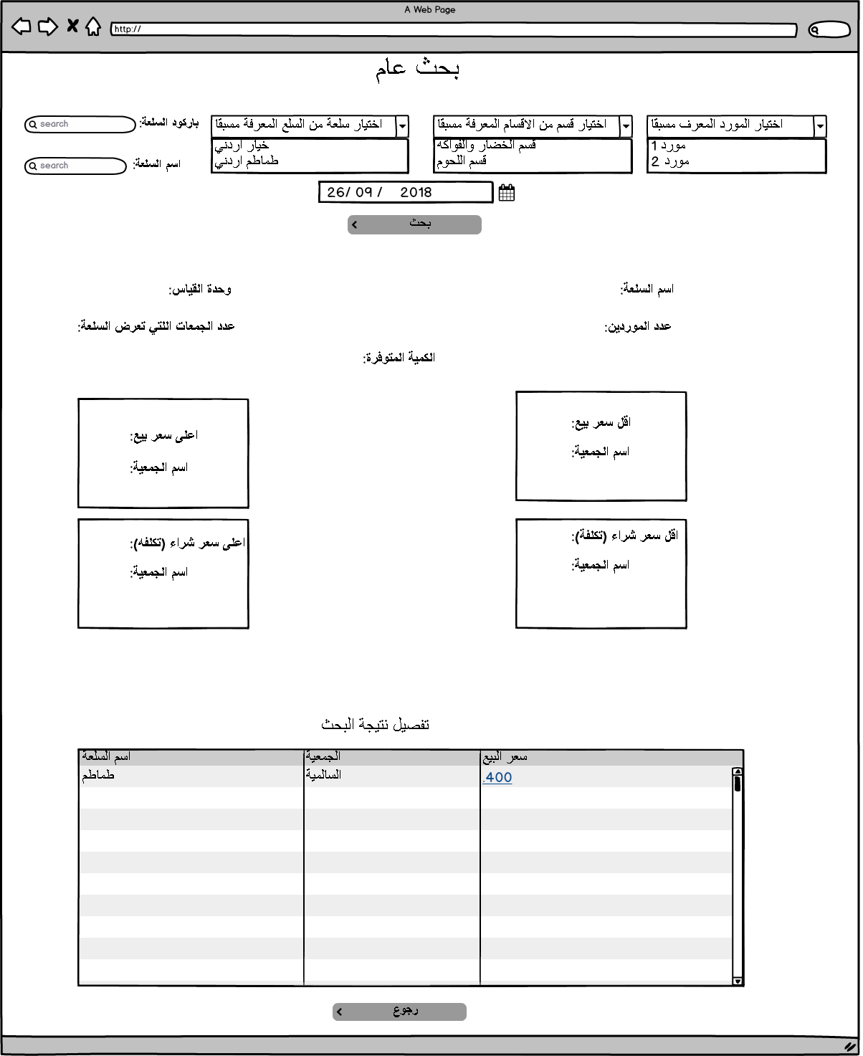

|  |  |  |  |  |  |  |  |  |
| --- | --- | --- | --- | --- | --- | --- | --- | --- |
| Item General Search Mockups Fields Description | | | | | | | | |
| Field | Description | | Type | Default value | Mandatory | | Length | Notes |
| Category list | To select targeted category which already defined in add category list. | | Drop down list | Non-Selected | Optional | | N/A | Could be changed to table popup. If it selected supplier list will be disabled. DB: PMON_ITEM_SECTIONS.MSTR_SECTION_NAME_AR |
| Subcategory list | Display subcategory based on the selected category | | Drop down list | Non-Selected | Optional | | N/A | DB:  PMON_ITEM_SECTIONS_DETALS.SECTION_NAME_AR |
| Supplier List | To select supplier of the item which already defined in add provider list. | | Drop down list | Non-Selected | Optional | | N/A | If selected category list will be disabled. DB:  PMON_SUPPLIER.SUPPLIER_DESC_AR |
| Item list | To select targeted Item. | | Drop down list | Non-Selected | Optional | | N/A | Could be changed to popup table  DB: PMON_GENERAL_ITEMS.ITEM_DESC_AR or PMON_GENERAL_ITEMS.ITEM_DESC_EN |
| Item Name Search | To insert the item name targeted for search | | Text field | Empty | Optional | | 50 | Supplier, Category, Item selections becomes disabled,  popup table displayed with all items related to text inserted to select the targeted item. DB:  PMON_GENERAL_ITEMS.ITEM_DESC_AR or PMON_GENERAL_ITEMS.ITEM_DESC_EN |
| Barcode Search | To insert the barcode number for the targeted item. | | Text field | Empty | Optional | | 20 | Supplier, Category, Items selection becomes disabled, popup table displayed with all items related to text inserted to select the targeted item.  DB:  PMON_GENERAL_ITEMS.ITEM_Code with reference to PMON_GEN_ITEM_RAWDATA.RAWDATA_BARCODE |
| Date of Monitoring | To insert the date of monitoring and to get the Item details as per the date inserted. | | Date | System Date | Mandatory | | N/A |  |
| Search Action | To Get the result based on the inserted search criteria. | | Button | Disabled | Mandatory | | N/A | Button becomes enabled once the user inserts a correct search criteria. |
| Back Button | To Back to Home Page of the price Monitoring | | Button | Enabled | Mandatory | | N/A |  |
| Search Result | | | | | | | | |
| Field name | | **Result as a label** | | | | **Notes** | | |
| Item Name | | Item Name. | | | | PMON_GENERAL_ITEMS.ITEM_DESC_AR or PMON_GENERAL_ITEMS.ITEM_DESC_EN | | |
| Lowest Selling Price per Item | | Selling price per unit. | | | | PMON_GENERAL_ITEMS.ITEM_Code with reference to PMON_GEN_ITEM_RAWDATA.RAWDATA_BARCODE with reference to PMON_DET_RAWDATA.RAWDATA_CSV_ITEM_SELLING_PRICE | | |
| Cooperative Name | | Name of the cooperative that item related to. | | | | PMON_GENERAL_ITEMS.ITEM_Code with reference to PMON_UNION_RAWDATA and PMON_DET_RAWDATA | | |
| Highest Selling Price per Item | | Selling price per unit. | | | | PMON_GENERAL_ITEMS.ITEM_Code with reference to PMON_GEN_ITEM_RAWDATA.RAWDATA_BARCODE with reference to PMON_DET_RAWDATA.RAWDATA_CSV_ITEM_SELLING_PRICE | | |
| Cooperative Name | | Name of the cooperative that item related to. | | | | PMON_GENERAL_ITEMS.ITEM_Code with reference to PMON_UNION_RAWDATA and PMON_DET_RAWDATA | | |
| Number of providers | | Total number of the providers for the item | | | | If supplier select list used in search the number will be one. | | |
| Number of cooperatives that sell the item | | Total number of the cooperative that sell the item and included in the search. | | | |  | | |
| Items included in the search table columns | | | | | | | | |
| Column Name | | Description | | | |  | | |
| Item Name | | Name of the Item | | | | PMON_DET_RAWDATA. RAWDATA_CSV_ITEM_NAME_AR with reference to PMON_UNION_RAWDATA and PMON_GENERAL_ITEMS.ITEM_Code | | |
| Cooperative Name | | Cooperative Name | | | | PMON_DET_RAWDATA. RAWDATA_MSTR_COOP_ID with reference to PMON_UNION_RAWDATA and PMON_GENERAL_ITEMS.ITEM_Code | | |
| Selling Price | | Selling Price for the Item | | | | The selling price will be as a link display Item Details screen once it is clicked from (PMON_DET_RAWDATA)  PMON_DET_RAWDATA.RAWDATA_CSV_ITEM_SELL_PRICE with reference to PMON_UNION_RAWDATA and PMON_GENERAL_ITEMS.ITEM_Code | | |

# Item Price Change within Period (مراقبة سعر سلعة خلال مده زمنية)

## Description

The Item price change within period will let the user to get the item price change during specific period in a specific cooperative with a total number of the price change for the item and a chart line for price changing during the start and end date, Add items to inspection table, the user has the following search criteria available:

1. Search by Barcode: The system display the Item has the barcode inserted.
2. Search by Item Name: The system will display all items related or close to the inserted text.

And the following Filters:

1. Cooperatives Selection: The user should determine a cooperative.
2. Category: The system will display all categories available based on the cooperative has been selected.
3. Item list Selection: The system will display all Items exists in the category selected.
4. The user should insert the start and end date for the search.

## Process identification card

|  |  |
| --- | --- |
| Process ID | PM - PM005 |
| Process name | The Item price change within period |
| Process purpose | Get the item price change during specific period |
| Initiator user | Inspections Department users. |
| Process owner | The admin of this process |
| Process type | Main Process |

## Process preconditions

.CSV file uploaded on CO-OPs System.

## Process input

.CSV file uploaded on CO-OPs system.

## Process output

The user will get the price change for specific item in within specific period.

## Process model



## Functional requirements

List of the functional requirements:

|  |  |  |  |
| --- | --- | --- | --- |
| REQ # | Requirement | Description | Notes |
| FR – PM - 001 | Cooperative Selection | All cooperatives in the system should be displayed. |  |
|  | Search on items by category | All Categories related to the cooperative selected should be displayed. |  |
|  | Search on Items by Supplier | All suppliers that exist in the cooperative selected should be displayed. |  |
|  | Search on items by barcode | The user can insert the item barcode to display the items details result for the selected cooperatives. |  |
|  | Search on items by Items Names | The user can insert the item name to display all related results for the selected cooperatives. |  |
|  | Items Select list | The user can select the item after select the category or the supplier. |  |
|  | Search result will display a table | Results will in a table contains the item name and the period inserted for the search and total number of the price changing. |  |
|  | The selling price for the item within the period should be detailed. | The system will display each price for each period within the start and end date inserted by the user. |  |
|  | Chart line for the price change | Chart line will be displayed for the price change within the period inserted by the user. |  |

## Use Cases

### Item Price Change within period of time

|  |  |
| --- | --- |
| Use Case ID | PM -UC04 |
| Use Case Name | Item Price Within Period of Time |
| Actors | Privileged users |
| Description | Get the price change within period for specific item in a specific cooperative. |
| Preconditions | .CSV file uploaded to CO-OPs system for the selected date. |
| Post conditions | Number of times the price for the item changed, chart line, dates that the item price has been changed, the user can add items to inspection table. |
| Business rules | 1. Results for the items should be displayed based on the search criteria inserted by the user. 2. Date should be inserted. |

**Main Flow**

|  |  |  |
| --- | --- | --- |
| # | Actor Action | System Response |
| 1 | The privileged user navigates to Item price change screen. | Item price change screen displayed and all fields with the default value. |
| 2 | The user selects the cooperative targeted for the search. | Cooperative selected, all category and suppliers list updated to the selected cooperative. (Mandatory step) |
| 3 | The user selects the provider or the category. | Option selected, and items list filtered based on the selection. |
| 4 | The user selects the item | Item selected. |
| 4 | The user inserts the start and end date. | Dates inserted. |
| 5 | The user clicks on search button. | Results display in the table. |
| 6 | The user clicks on total number of prices changing for the item link. | The user redirected to the second screen which have a detailed table and chart line for the price change. (Optional Step) |
| 7 | The user select items and click on send to inspection table button. | Items selected sent to the inspection table. |
|  |  |  |
|  |  |  |

**Alternative Flows**

|  |  |  |
| --- | --- | --- |
| # | Actor Action | System Response |
| 1 | The user inserts the item barcode. | Category list, item list, supplier list, search box should be disabled. |
| 2 | The user inserts the date for the search. | Date inserted. |
| 3 | The user clicks on search button. | Item details displayed. |
| Second flow | | |
| 1 | The user inserts the item name in search box. | Category list, item list, supplier list, barcode text box should be disabled. |
| 2 | The user inserts the date for the search. | Date inserted. |
| 3 | The user clicks on search button. | Items related details displayed in the table. |
|  |  |  |
|  |  |  |
|  |  |  |

**Exceptional Flows**

|  |  |  |
| --- | --- | --- |
| # | Actor Action | System Response |
| 1 | The user does not select the cooperatives targeted for the search. | Cooperatives not selected. |
| 2 | The user inserts the search date. | Date inserted. |
| 3 | The user clicks on search button. | No results and error message displayed. |
|  |  |  |
|  |  |  |

**System Messages:**

|  |  |  |  |
| --- | --- | --- | --- |
| # | Actor Action | Message Type | System Response |
| 1 | The user does not insert the search date and click on search button. | Error Message | يرجى ادخال التاريخ |
| 2 | The user clicks on search button without insert any field. | Error Message | يرجى ادخال الحقول الالزاميه |
| 3 | The user insert data that does not display any search result. | Error Message | لا يوجد نتائج للبحث |
| 5 | Missed detail for Item displayed in the table after search. | Error Message for each column | لم يتم تزويد المعلومات من قبل الجمعيه |
| 6 | The user select items and clicked on send to inspection table | Hint Message | تم ارسال السلع الى جدول التفتيش المباشر |

### Task screens and fields

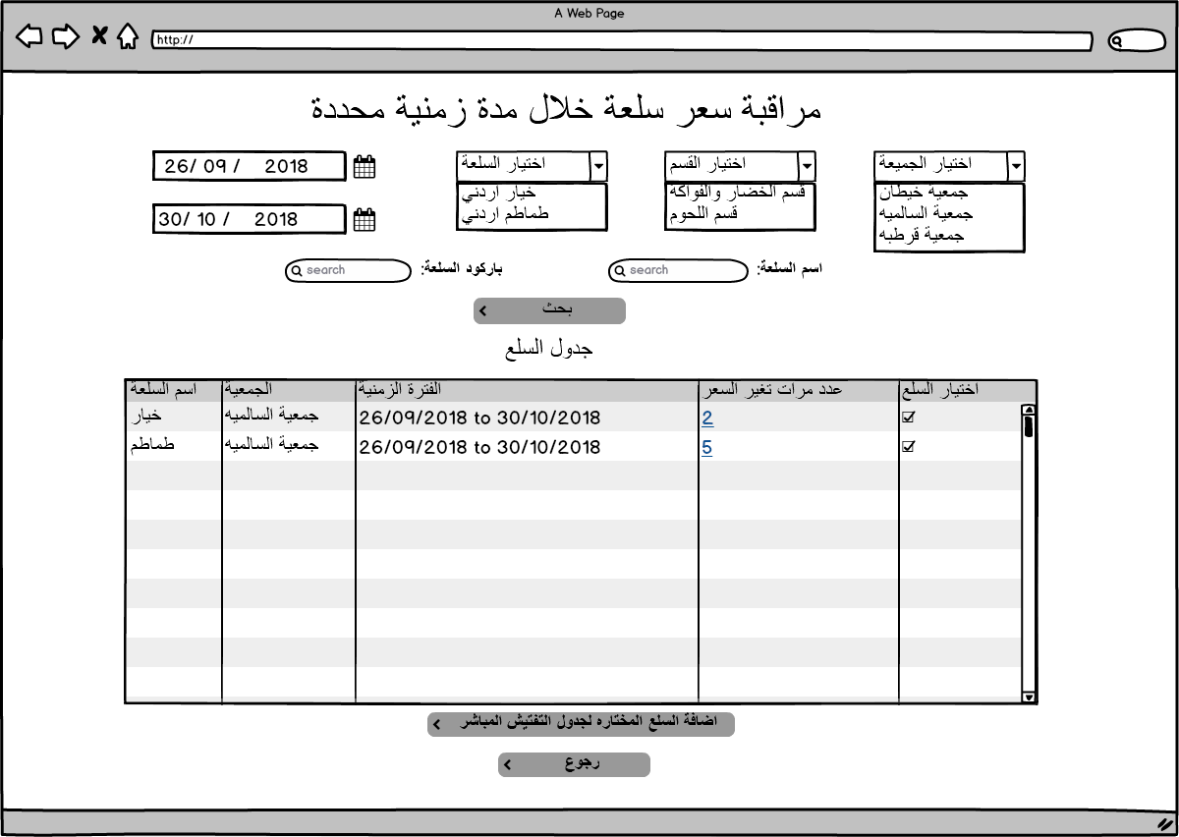

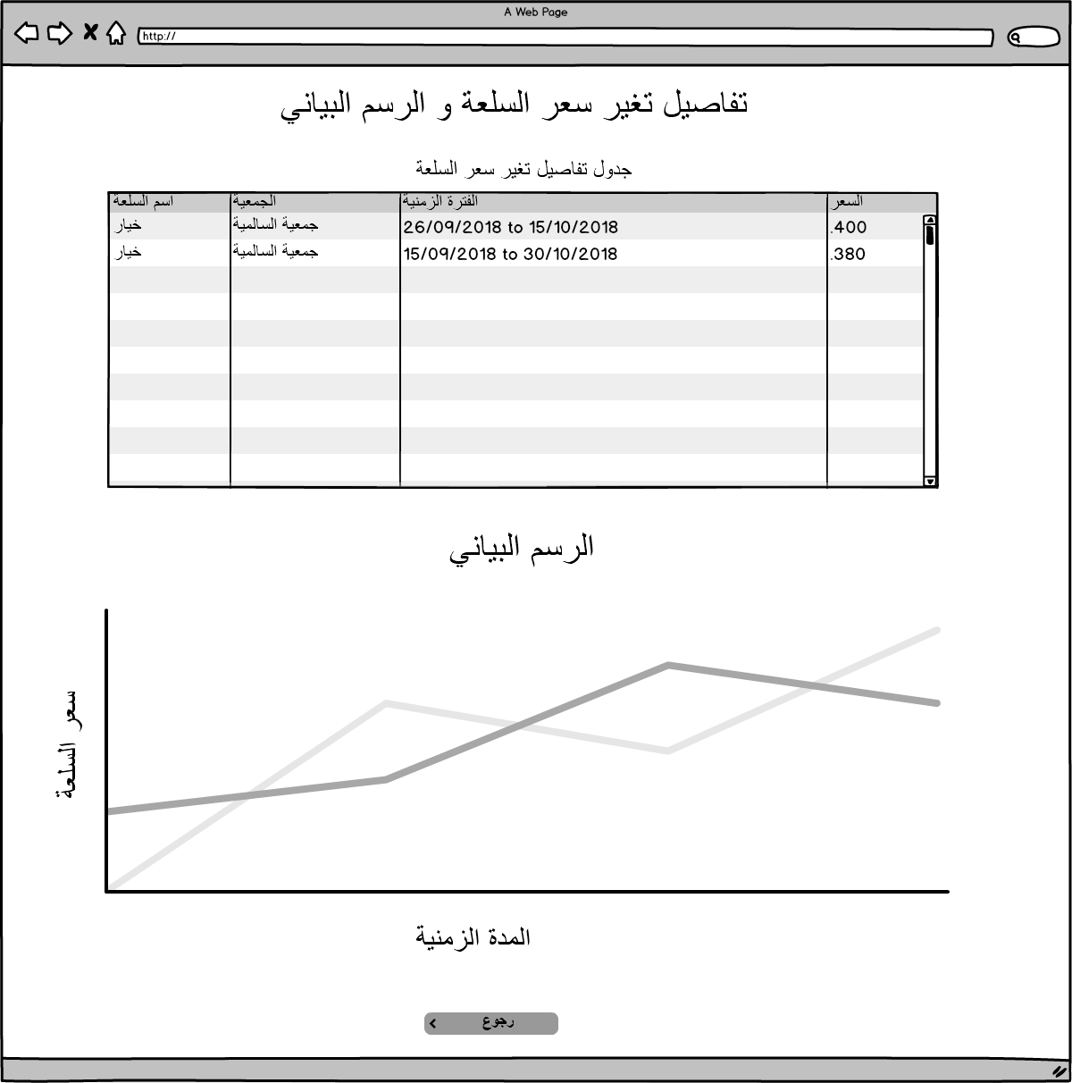

|  |  |  |  |  |  |  |  |  |
| --- | --- | --- | --- | --- | --- | --- | --- | --- |
| Item Price Monitoring within Period of Time. | | | | | | | | |
| Field | Description | | Type | Default value | Mandatory | | Length | Notes |
| Cooperative list | To select targeted cooperative. | | Drop down list | Non-Selected | Mandatory | | N/A | PMON_DET_RAWDATA.RAWDATA_MSTR_COOP_ID |
| Category list | All categories in the selected cooperative should be displayed. | | Drop down list | Non-Selected | Optional | | N/A | Could be changed to popup table. If it selected supplier list will be filtered to match the supplier in the selected category.  DB: PMON_DET_RAWDATA.RAWDATA_CSV_ITEM_CATEGORY |
| Supplier List | All suppliers in the selected cooperative should be displayed. | | Drop down list | Non-Selected | Optional | | N/A | If selected category list will be filtered to match the categories that the suppliers have items in.  DB:  PMON_DET_RAWDATA.RAWDATA_CSV_SUPPLIER_NAME |
| Item list | Items will be filtered based on the selection for the supplier and the category. | | Drop down list | Non-Selected | Optional | | N/A | Could be changed to popup table.  DB: PMON_DET_RAWDATA.RAWDATA_CSV_ITEM_NAME_AR |
| Item Name Search | To insert the item name targeted for search based on the cooperative, category and supplier if it selected. | | Text field | Empty | Optional | | 50 | Popup table displayed with all items related to the inserted text in search box.  Will search in PMON_DET_RAWDATA. RAWDATA_CSV_ITEM_NAME_AR or PMON_DET_RAWDATA. RAWDATA_CSV_ITEM_NAME_EN |
| Barcode Search | To insert the barcode number for the targeted item. | | Text field | Empty | Optional | | 20 | DB: PMON_DET_RAWDATA.RAWDATA_CSV_ITEM_BARCODE |
| Start date | To insert the start date of monitoring and to get the Item details as per the date inserted. | | Date | System Date | Mandatory | | N/A | Date should be less than the end date. |
| End date | To insert the end date for the period targeted for monitoring. | | Date | System Date | Mandatory | | N/A | Date should not be more than the system date. |
| Add to inspection table | To send the selected items from search result table to inspection table | | Button | Enabled | Optional | | N/A | Items added and classified in inspection details screen. Note: the details of the items sent to the inspection table in system date. DB: INSP_PRICE_INSPECTION |
| Search Action | To Get the result based on the inserted search criteria. | | Button | Disabled | Mandatory | | N/A | Button becomes enabled once the user inserts a correct search criteria. |
| Back Button | To Back to Home Page of the price Monitoring | | Button | Enabled | Mandatory | | N/A |  |
| Item Price Change Details and Chart Line Screen | | | | | | | | |
| Details Table | Highlight the price for the item for each time | | table | N/A | Mandatory | | N/A | Described in search result section. |
| Chart Line | Y axis is the price and X axis is the time | | Chart Line | N/A | Mandatory | | N/A | Described in search result section. |
| Search Result | | | | | | | | |
| Column Name | | **Column Description** | | | | **Notes** | | |
| Item Name | | Item Name. | | | | PMON_DET_RAWDATA.RAWDATA_CSV_ITEM_NAME_EN or PMON_DET_RAWDATA.RAWDATA_CSV_ITEM_NAME_AR | | |
| Cooperative Name | | Name of the cooperative that item related to. | | | | PMON_DET_RAWDATA.RAWDATA_MSTR_COOP_ID | | |
| Period inserted. | | The start and end date inserted. | | | | From date - to date | | |
| Number of times the price has changed. | | Total number of the price changed. As link if clicked redirect the user to details table and chart line (Item price change chart). | | | |  | | |
| Check box | | To let the user check the item and send it to inspection table. | | | |  | | |
| Item Price Change Details and Chart Line Screen | | | | | | | | |
| Column Name | | **Column Description** | | | | **Notes** | | |
| Item Name | | Item Name. | | | |  | | |
| Cooperative Name | | Name of the cooperative that item related to. | | | |  | | |
| The period with the same price | | The period that have the same price | | | |  | | |
| Item Price | | Item Selling Price | | | |  | | |

# Item Price Average within Period (متوسط سعرسلعة خلال مدة زمنية)

## Description

The Item price average within period will let the user to get the item defined price average during specific period for selected cooperatives with a chart column for the price average for the period inserted and the cooperatives included in the search, the user has the following search criteria available:

1. Search by Barcode: The system display the Item has the barcode inserted.
2. Search by Item Name: The system will display all items related or close to the inserted text.

And the following Filters:

1. Cooperatives Selection: The user should determine a cooperative.
2. Category: The system will display all categories added by the user in Add category screen.
3. Item list Selection: The system will display all Items added by the user in add items screen.
4. The user should insert the start and end date for the search.

## Process identification card

|  |  |
| --- | --- |
| Process ID | PM - PM005 |
| Process name | The Item average price change within period |
| Process purpose | Get the item average price change during specific period with a chart column |
| Initiator user | Inspections Department users. |
| Process owner | The admin of this process |
| Process type | Main Process |

## Process preconditions

.CSV file uploaded on CO-OPs System.

## Process input

.CSV file uploaded on CO-OPs system.

## Process output

The user will get the Item price average for specific item within specific period.

## Process model



## Functional requirements

List of the functional requirements:

|  |  |  |  |
| --- | --- | --- | --- |
| REQ # | Requirement | Description | Notes |
| FR – PM - 001 | Cooperative Selection | All cooperatives in the system should be displayed. |  |
|  | Search on items by category | All Categories added by the user in add category screen should be displayed. | (Note only mapped categories displayed and mapped cooperatives included in the search) |
|  | Search on Items by Supplier | All suppliers that exist in add supplier screen should be displayed. | (Note only mapped suppliers displayed and mapped cooperatives included in the search) |
|  | Search on items by barcode | The user can insert the item barcode to display the items details result for the selected cooperatives. |  |
|  | Search on items by Items Names | The user can insert the item name to display all related results for the selected cooperatives. |  |
|  | Items Select list | The user can select the item after select the category or the supplier which will display all items mapped to the supplier or to the category. | (Note only mapped Items displayed and mapped cooperatives included in the search) |
|  | Search result will display a table | Results will in a table contains the cooperative name, the item name and the item price average within the inserted period. |  |
|  | Chart column for the price Average with the cooperative | Chart column will be displayed for the price Average within the period inserted by the user as Y axis and a column for each cooperative included in the search on X axis. | Please refer to the mockup chart column for more details. |

## Use Cases

### Item Price Average within period

|  |  |
| --- | --- |
| Use Case ID | PM -UC06 |
| Use Case Name | Item Price Average within period |
| Actors | Privileged users |
| Description | Get the Item price Average in different cooperatives within period. |
| Preconditions | .CSV file uploaded to CO-OPs system for the selected date. |
| Post conditions | Item Average Price within Period, chart column. |
| Business rules | 1. Results for the items should be displayed based on the search criteria inserted by the user. 2. Date should be inserted. |

**Main Flow**

|  |  |  |
| --- | --- | --- |
| # | Actor Action | System Response |
| 1 | The privileged user navigates to Item Price Average within Period of Time | Item Price Average within Period screen displayed and all fields with the default value. |
| 2 | The user selects the provider or the category. | Option selected, items list filtered based on the selection and the mapped items in add category or add provider only displayed. (Cooperative shuttle field disabled.) |
| 3 | The user selects the item | Item selected. |
| 4 | The user inserts the start and end date. | Dates inserted. |
| 5 | The user clicks on search button. | Results display in the table. |
|  |  |  |
|  |  |  |

**Alternative Flows**

|  |  |  |
| --- | --- | --- |
| # | Actor Action | System Response |
| 1 | The user select the cooperatives targeted | Cooperatives selected. |
| 2 | The user inserts the item barcode. | Category list, item list, supplier list, search box should be disabled. |
| 3 | The user inserts the date for the search. | Date inserted. |
| 4 | The user clicks on search button. | Item details displayed. |
| Second flow | | |
| 1 | The user select the cooperatives targeted | Cooperatives selected. |
| 2 | The user inserts the item name in search box. | Category list, item list, supplier list, barcode text box should be disabled. |
| 3 | The user inserts the date for the search. | Date inserted. |
| 4 | The user clicks on search button. | Items related details displayed in the table. |
|  |  |  |
|  |  |  |
|  |  |  |

**Exceptional Flows**

|  |  |  |
| --- | --- | --- |
| # | Actor Action | System Response |
| 1 | The user does not select the cooperatives targeted for the search. | Cooperatives not selected. |
| 2 | The user inserts the search date. | Date inserted. |
| 3 | The user clicks on search button. | No results and error message displayed. |
|  |  |  |
|  |  |  |

**System Messages:**

|  |  |  |  |
| --- | --- | --- | --- |
| # | Actor Action | Message Type | System Response |
| 1 | The user does not insert the search date and click on search button. | Error Message | يرجى ادخال التاريخ |
| 2 | The user clicks on search button without insert any field. | Error Message | يرجى ادخال الحقول الالزاميه |
| 3 | The user insert data that does not display any search result. | Error Message | لا يوجد نتائج للبحث |
| 5 | Missed detail for Item displayed in the table after search. | Error Message for each column | لم يتم تزويد المعلومات من قبل الجمعيه |

### Task screens and fields

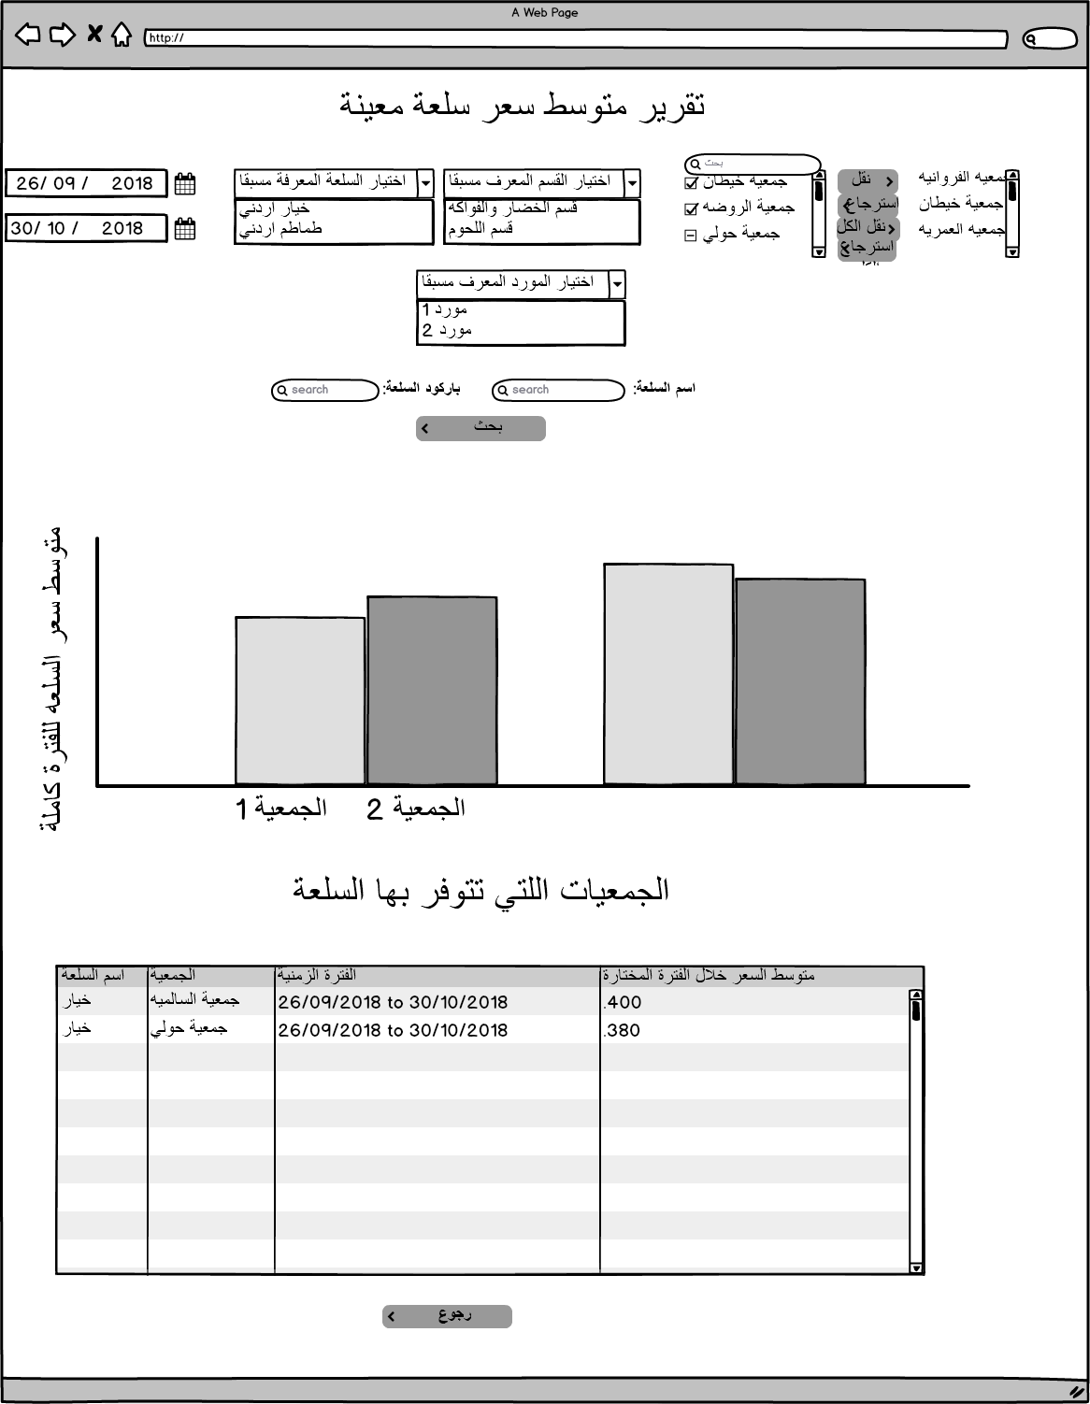

|  |  |  |  |  |  |  |  |  |
| --- | --- | --- | --- | --- | --- | --- | --- | --- |
| Item Price Average within Period of Time. | | | | | | | | |
| Field | Description | | Type | Default value | Mandatory | | Length | Notes |
| Cooperative list | To select targeted cooperative. | | Drop down list | Non-Selected | Mandatory | | N/A | Select distinct PMON_GEN_ITEM_RAWDATA .RAW_DATA_COOP_ID |
| Category list | Category list will display already added categories in add category screen. | | Drop down list | Non-Selected | Optional | | N/A | Only mapped cooperatives will be included in the search and cooperative shuttle field becomes disabled.  DB: Select PMON_ITEM_SECTIONS.MSTR_SECTION_NAME_AR FROM |
| subCategory list | Category list will display already added categories in add category screen. | | Drop down list | Non-Selected | Optional | | N/A | Only mapped cooperatives will be included in the search and cooperative shuttle field becomes disabled.  Select PMON_ITEM_SECTIONS_DETALS.SECTION_NAME_AR where PMON_ITEM_SECTIONS.MSTR_SECTION_NAME_AR = from value |
| Supplier List | Supplier list will display already added suppliers in add suppliers screen. | | Drop down list | Non-Selected | Optional | | N/A | Only mapped cooperatives will be included in the search and cooperative shuttle field becomes disabled.  Select PMON_SUPPLIER. SUPPLIER_DESC_AR from PMON_SUPPLIER; |
| Item list | Items will be filtered based items already defined in defined Items screen. | | Drop down list | Non-Selected | Optional | | N/A | Only mapped cooperatives will be included in the search and cooperative shuttle field becomes disabled.  Select PMON_GENERAL_ITEMS.ITEM_DESC_AR or PMON_GENERAL_ITEMS.ITEM_DESC_EN from PMON_GENERAL_ITEMS |
| Item Name Search | To insert the item name targeted for search based on the cooperative, category and supplier if it selected. | | Text field | Empty | Optional | | 50 | Popup table displayed with all items related to the inserted text in search box.  Cooperatives selection becomes mandatory. And search result display the items shared between the selected cooperatives.  DB: PMON_GENERAL_ITEMS.ITEM_DESC_AR or PMON_GENERAL_ITEMS.ITEM_DESC_EN |
| Barcode Search | To insert the barcode number for the targeted item. | | Text field | Empty | Optional | | 20 | PMON_GENERAL_ITEMS.ITEM_UNIV_BARCODE |
| Start date | To insert the start date of monitoring and to get the Item details as per the date inserted. | | Date | System Date | Mandatory | | N/A | Date should be less than the end date. |
| End date | To insert the end date for the period targeted for monitoring. | | Date | System Date | Mandatory | | N/A | Date should not be more than the system date. |
| Search Action | To Get the result based on the inserted search criteria. | | Button | Disabled | Mandatory | | N/A | Button becomes enabled once the user inserts a correct search criteria. |
| Back Button | To Back to Home Page of the price Monitoring | | Button | Enabled | Mandatory | | N/A |  |
| Item Price Change Details and Chart Line Screen | | | | | | | | |
| Details Table | Highlight the average price for the item for each period and each cooperative | | table | N/A | Mandatory | | N/A | Described in search result section. |
| Chart Column | Y axis is the price and X axis is the time | | Chart Line | N/A | Mandatory | | N/A | Described in search result section. |
| Search Result | | | | | | | | |
| Column Name | | **Column Description** | | | | **Notes** | | |
| Item Name | | Item Name. | | | |  | | |
| Cooperative Name | | Name of the cooperative that item related to. | | | |  | | |
| Period inserted. | | The start and end date inserted. | | | |  | | |
| Average Price within the period | | Total Prices for the item in the period / number of days | | | |  | | |
| Chart Column | | | | | | | | |
| Column Name | | **Column Description** | | | | **Notes** | | |
| Y axis | | Average Price | | | | Please refer to mockup for more details | | |
| X axis | | Cooperative Name | | | | Please refer to mockup for more details | | |